Chapter 3. Graphic User Interface (GUI)

3.1 Introduction
The VPON DVR can be configured using either the supplied remote control unit (or a keyboard) or a mouse. This chapter covers mouse operation. The VPON DVR must be in GUI mode for mouse operation. Under GUI mode, keyboard is used ONLY for data entry.

Local surveillance GUI:
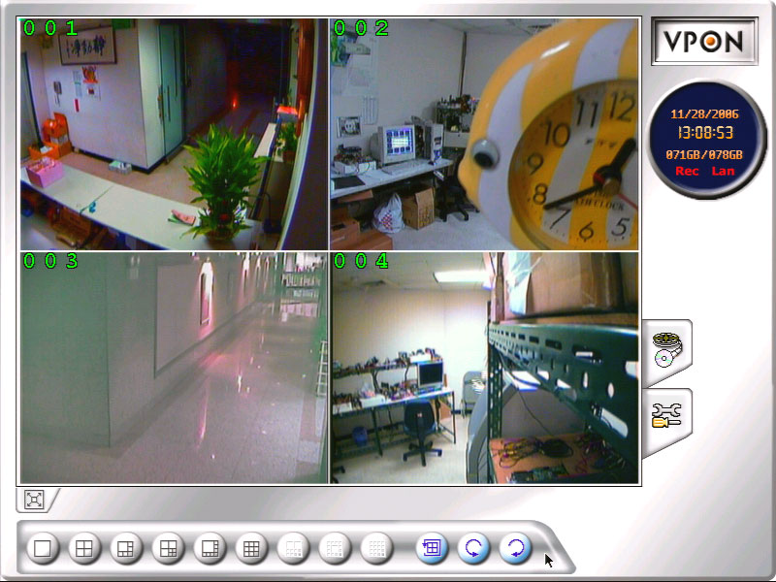

3.2 Surveillance screen panel
The Surveillance Screen Panel enables you to define which live images are displayed on screen.


A B C

A. Selectable 1 / 4 / 6 / 7 / 8 / 9 / 10 / 13 /16 split-screen display
B. Use the sequence button to automatically cycle through all the connected cameras
- The arrow buttons to cycle through all connected cameras

Enlarge button 
Click the enlarge button to switch to full screen display live Video.
Double click the right button of mouse to switch back normal display live video.

3.3 Setup Video Quality
Use the set quality button  to set all the video parameters for the cameras connected to the VPON DVR.
- Please change to single screen as following first.
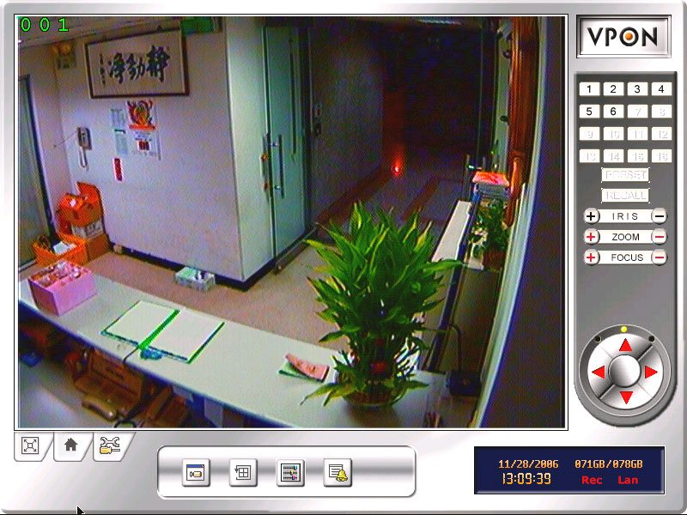

2. Press the set quality button, you can see the Brightness , Contrast , Saturation , Hue , Quality (All) control panel.
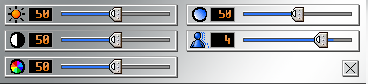
Brightness- adjusts the amount of light or brightness for the selected camera according to your preference.
Contrast - adjusts the difference between light and dark areas or contrast for the selected camera according to your preference.
Saturation - adjusts the amount of color for the selected camera.
Hue - adjusts the dominant color for the selected camera.
Quality (All) - adjusts the video quality for all cameras. The default setting is 3. We recommend that you do not set this to 5 to avoid a slower rate of video transmission and using up a significant amount of hard disk space.

3.4 PTZ Control

PTZ panel
Use the PTZ panel to control PTZ (Pan, Tilt, Zoom) enabled cameras. This panel is displayed when change to single screen.

The PTZ panel can only be used in the Surveillance Screen. You can set and recall up to 6 preset configurations for each camera using the following buttons:
Preset buttons- save the current pan, tilt, zoom, and focus settings in one of 6 preset configurations.
Recall buttons- recall the selected preset configuration.
ZOOM buttons - adjust the zoom to provide a more closer or wider view of the subject.
FOCUS buttons - adjust the focus of the camera.
Speed buttons - Adjust the speed of the selected PTZ camera.
Pan and tilt buttons - Adjust the pan and tilt of the selected camera.
To set a camera configuration:
1. Select a camera using the numbered buttons (1~16) on the Surveillance Panel.
2. Adjust the Zoom, Focus, Speed, Pan and Tilt buttons until the camera is configured correctly.
3. Press a Set button to save the configuration.
The configuration you have saved can now be recalled with the corresponding Call button.

3.5 PLAY button 
Click the PLAY button to display a list of all the recordings files in the hard disk.

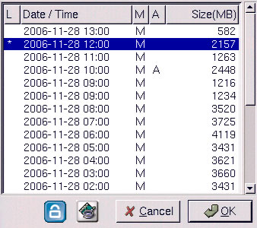
The alarm condition, which caused the file to be recorded, is indicated in the list. For instance, in the screen shot shown here, the letter M next to a file indicates that the file was recorded after the camera detected motion. Pick a recording from the displayed list and click to play. The recording will play on screen. Click the close playback screen  button to return to live images from the connected cameras.

Click lock file button, the file is locked and cannot be deleted or over-written. The locked file is represented by an asterisk (*) next to it. To unlock a file, follow the same procedure and select the Unlock File! Option from the menu.
Following section explains each of the buttons on the playback screen when playback recording files.
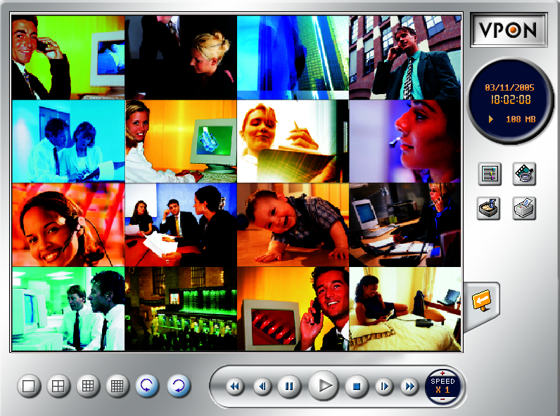
Selectable 1 / 4 / 9/ 16 split-screen display.
The arrow buttons to cycle through all connected cameras

Selectable Speed / Play / Pause / Stop / Rewind / Seek Backward / Seek Forward / Fast Forward / Fast Backward

Searching for a file 
Search by Time - searches the list of recorded files for the specified recording time.
Search by Event - searches the list of recorded files for the specified event such as a motion or a GPIO trigger that occurred within the specified time interval.
Thumbnail Browse –finds video images and selects them for processing individually, in whole folders, using a simple time selector and built-in image viewer .you can check out the results with the built-in viewer.

Thumbnail Browse
- Select search starting time and camera.
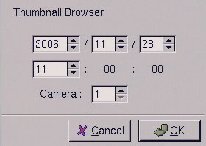
- Using a simple time selector and built-in image viewer .you can check out the results with the built-in viewer.
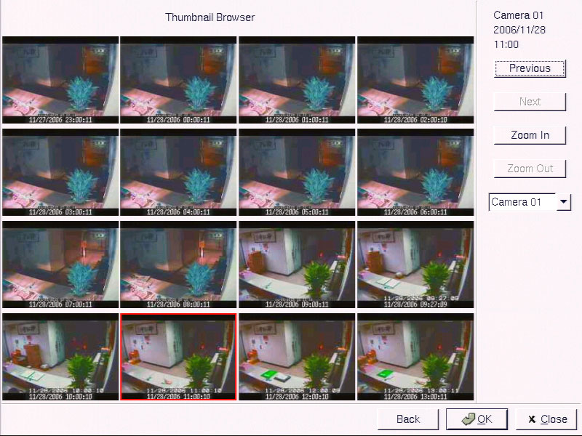

Previous - Search forward

Next - Search backward
Zoom in - The whole Thumbnail search was divided to three layers. The first layer is hourly based. Each picture on the windows is the first picture of that hour。When select a specific hour to do Zoom in, it goes into second layer. The second layer displays 16 pictures based on evenly divided time slots in this hour。Then if any one of these pictures is selected to do Zoom in，it goes into the third layer. This layer displays 16 pictures from left to right, that are most close to the time slot of layer two。
Zoom out - Back to one layer up。

Back- Back to Thumbnail Browser window
Ok - Start playback recorded file

Backing up the data 
If the VPON DVR is equipped with CD/RW drive, you can back up your recorded files to a CD or USB hard drive.
Note: The VPON DVR will begin to take the time to collect data when the required data has been collected, the backup can begin.

Status Button
The status panel displays the playback status of the current recording. The aqua line (Data) indicates record data over a one hour time interval. The yellow bars (Motion) indicate the instance when motion was detected. The (GPI) indicate when a GPI event was detected. The moving orange line indicates the current playback status. Click anywhere on the Data, Motion, or GPI lines to start playback from the required point.

Close playback screen
Stop playing recording file and back to the recording file list menu.

3.6 I/O button 
Click the I/O button to display the I/O panel.
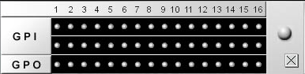
When an alarm has been triggered, the GPI and GPO that are connected will show the status of the input or output device. GPI devices will show NC (normally closed) or NO (normally open) as the status of the switch while GPO devices will show On or Off as their status.

3.7 Setup 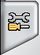
Click the Set Up button to display the set up menus used to configure the VPON DVR. There are four parts to the Set Up menu - System Setup, Record Setup, Alarm, Motion Detection. This section explains each of the menu pages in turn.

[System setup]

3.7.1 Password Protect
The Password Protect screen helps you to enable password protection, set administrator and user passwords, set the auto lock period and lock the system immediately. Enabling password protection prevents unwanted users from accessing or configuring the VPON DVR.
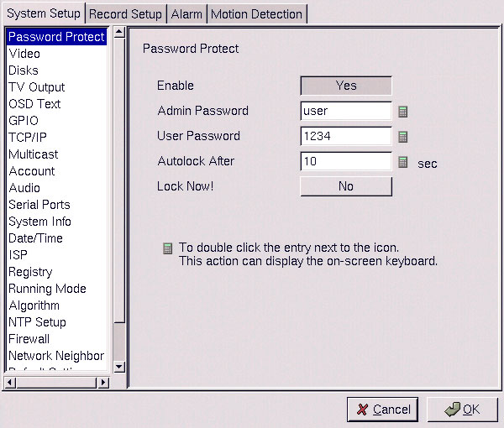
Enter new passwords for Admin and User in the corresponding fields. Set an auto lock time if required in the Auto lock after field. The auto lock function locks the system after a given time and a password is required to unlock it. Click Lock Now! to lock the system immediately.
Note: If you do not have a keyboard connected to the system, you can use the on-screen keyboard to enter your passwords. All the fields that can be edited using the on-screen keyboard are indicated by the on-screen keyboard icon. Double-click the field to display the on-screen keyboard. Use the mouse to enter characters for the required field.
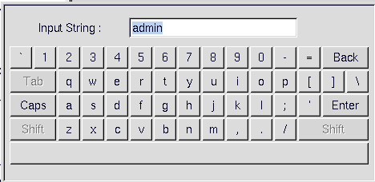

3.7.2 Video
The Video menu enables you to set video parameters such as the video standard and so on for each of the connected cameras. Audio and Multicast function enable or disable. Select the camera from the Camera drop-down box and fill in the details in each field as required using the mouse (recommended) or keyboard. Select the type of PTZ cameras used and set each camera that has one connected to Yes. The timeout value represents the time given to the cameras to respond to a command. Don’t forget to setup PTZ ID. Use the keyboard or mouse (recommended) to complete each field and click OK to save changes.
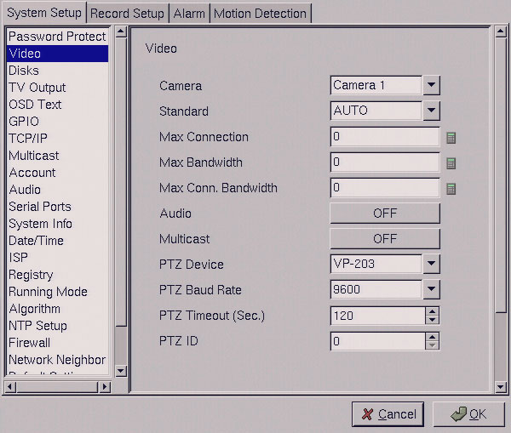

3.7.3 Disks
Use the Disks menu to configure network disks that the VPON DVR uses to record data. If no disk is connected, (No Device) appears in the Disk Device field.
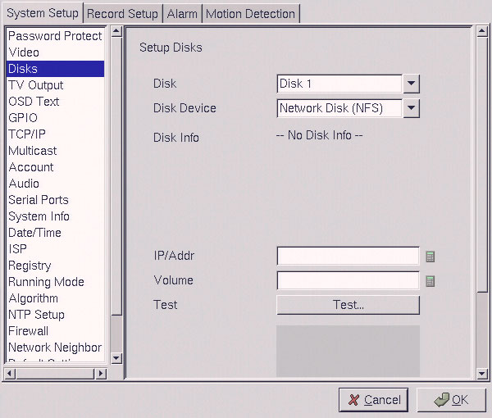
Use the keyboard or mouse to enter the IP address and Volume of any connected network disk. Click on the Test button to test if the drive is working correctly.

3.7.4 TV output
Use the TV Output menu to configure the video output for the VPON DVR. The VPON DVR can support standard VGA computer monitors or TV type screens. Set the device type, standard, outputs and other parameters. Set the Camera (From) and Camera (To) options to specify the range of cameras that are displayed in the cyclic display mode.
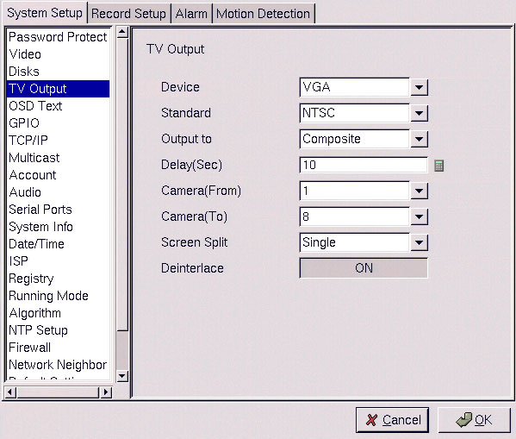
Use the keyboard or mouse (recommended) to set each field. Ensure each field is set correctly before clicking OK. If parameters are set incorrectly it could result in the display becoming unreadable and very difficult to correct.

3.7.5 OSD Text
Use the OSD Text menu to assign text for each of the connected cameras. For instance, you may like to have text saying “c1” on the image from a camera installed in the c1.
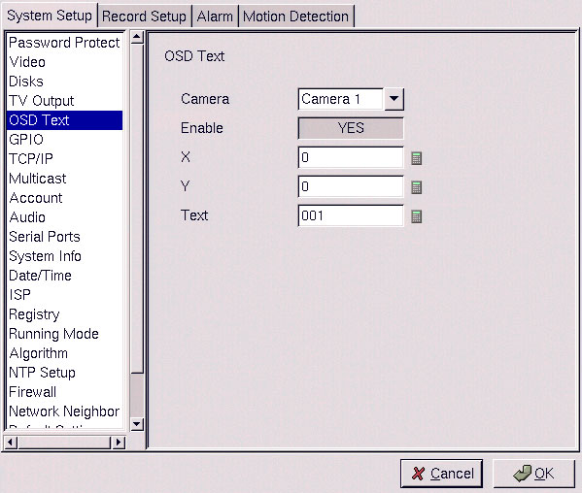
To display the OSD text:
- Select the desired camera from the Camera drop-down box.
- Click the Enable field to display the text.
- Adjust the position of the text display on the image using the X and Y parameters. A value of X=0 and Y=0 would result in the text appearing at the top left corner of the camera image. Increasing the value of Y moves the text down the screen. Increasing the value of X moves the test the right. Enter the text to be displayed in the Text field.
- Use the mouse to complete the fields and click OK to save changes.

3.7.6 GPIO
The GPIO (general purpose input output) menu enables you to view the status of the input and output devices such as switches, sensors, LEDs, and so on and view their status. These devices can be attached to the unit to turn internal or external alarms (outputs) on or off when the specified input changes. When an alarm has been triggered, the GPI and GPO that are connected will show the status of the input or output device. GPI devices will show NC (normally closed) orNO (normally open) as the status of the switch. Depending on the input, you can change the status of the GPO devices to On or Off as required.
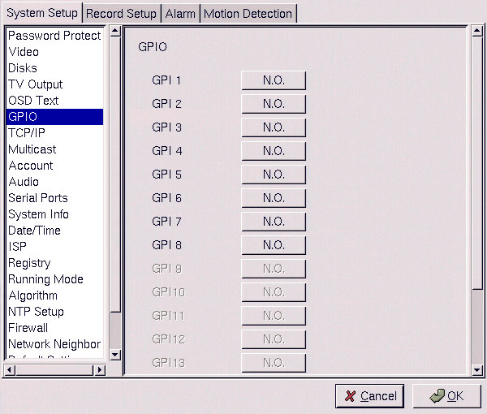
Change the GPO status as needed. Make sure that the devices are working by checking the actual physical status of the inputs and outputs after making changes in this menu.
NOTE: Enable GPIO function may cause system efficiency drop down.

3.7.7 TCP/IP
Use the TCP/IP menu to enter TCP/IP address details for the VPON DVR.
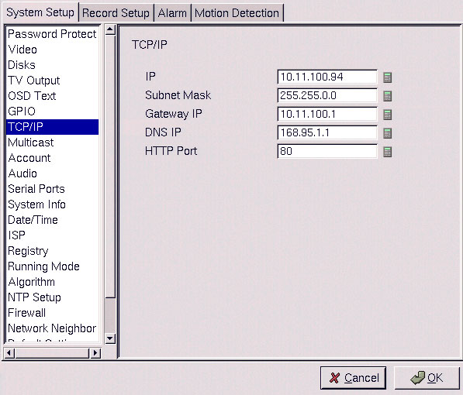
Use the keyboard or mouse (recommended) to complete each field and click OK to save changes.

3.7.8 Multicast

TCP/IP
Group Default setting is :239.192.10.10
Port: 18201
TTL:1

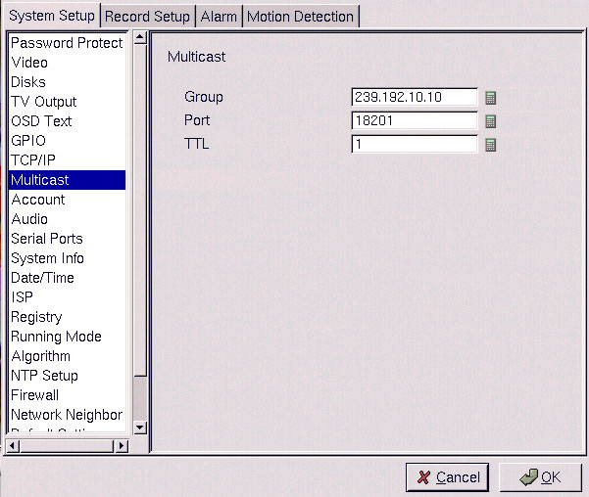

3.7.9 Account
Use the Account menu to set up an administrator name and password as well as the super user name and passwords. You can also use this menu to set up to 256 additional users, their passwords and their permissions on the system. Select the user number and assign a Name and password to it. Click the PTZ, Playback, and Audio fields to enable access to these properties for the selected user. Select the cameras that you want the user to have access to and set them to Yes.
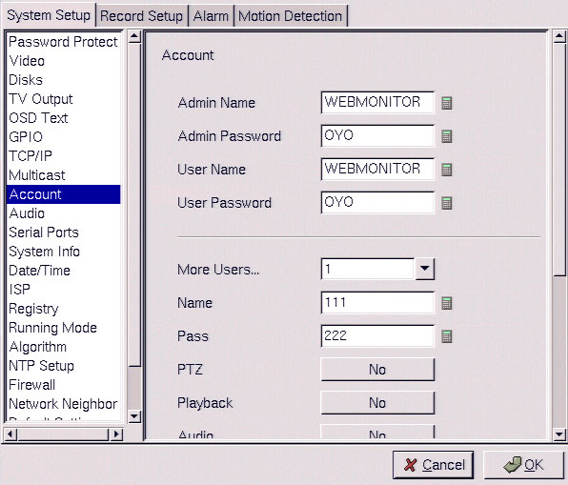
Note: It is important that you set up the super user name and password. The super user is different from the administrator and has access to only live videos and playback files. Use the More Users field to change the authorities of Internet users. Use the keyboard or mouse (recommended) to complete all the fields and click OK to save changes.

3.7.10 Audio
Use the Audio menu to set Speaker function.
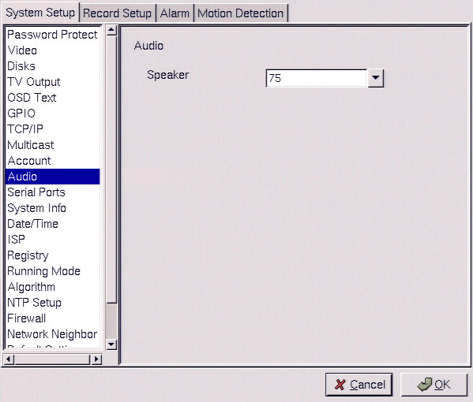

3.7.11 Serial ports
The serial ports are used to attach PTZ camera control cables, external or internal modems to the VPON DVR. Use the Serial Port menu to set parameters for the two serial ports.
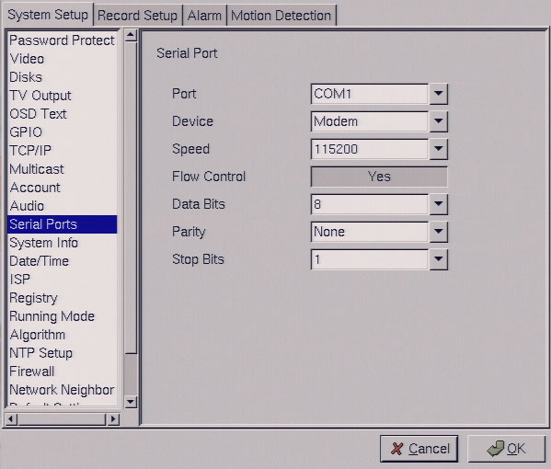

Use the keyboard or mouse (recommended) to set all parameters and click OK to save changes.

3.7.12 System info
Use the System Info menu to display the system information such as disk parameters, TCP/IP properties, firmware information, and so on, on the screen.
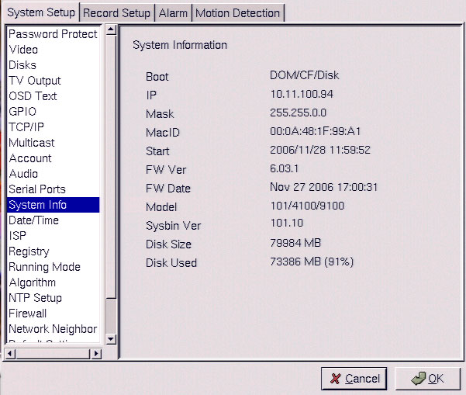
There are no configurable fields on this page. Click OK or Cancel to leave the screen.

3.7.13 Date/Time
Use the Date/Time menu to set the precise time and date on the system. You can also set the local time zone in the T.Zone field. Use the keyboard or mouse (recommended) to set all fields and click OK to save changes.

3.7.14 ISP
If you are using dial-up access to the Internet, use the ISP menu to enter details of your Internet Service Provider. Use the keyboard or mouse (recommended) to complete all fields and click OK to save changes.

3.7.15 Registry
The Registry menu enables you to set up the registry server for your device. If you are using a dynamic IP address for the VPON DVR, you can set up the device to post its IP address to the VPON registry server. You can then look up your IP from the MAC address or server name. You can use the registry server to give a name to the VPON DVR also.
Use the keyboard or mouse (recommended) to complete all fields and click OK to save changes.

3.7.16 Running mode
Use the Running Mode menu to switch between Network Mode and ISP Mode, and between Mouse Mode and IR Remote Control Mode.
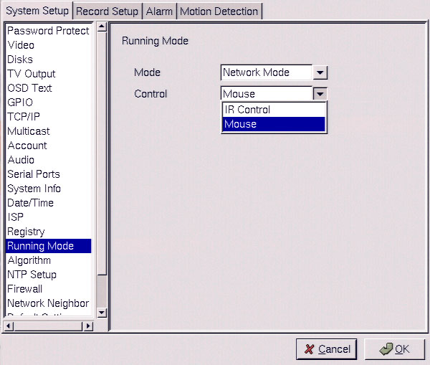

3.7.17 Algorithm
Use the Dimension option to set the resolution of the video. We default resolution setting is360x240.
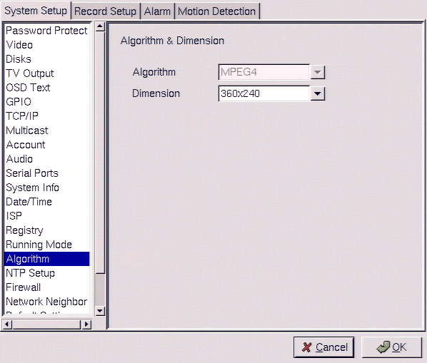
Use the keyboard or mouse (recommended) to complete each field and click OK to save changes.

3.7.18 NTP setup
Use the NTP Setup menu to enter details of the Network Time Protocol (NTP) server used to synchronize the time of the device with the network.
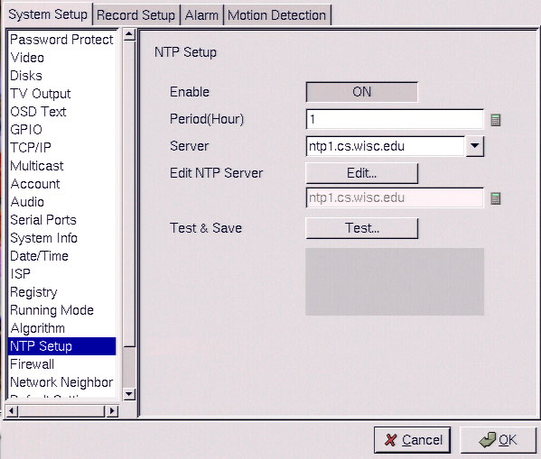
Use the keyboard or mouse (recommended) to complete all fields. After making the changes, click on the Test & Save button to verify that the server is operational. Click OK to save changes.

3.7.19 Firewall
The function of Firewall is to protect your DVR system from Internet attacks so that you can hook up your VPON to Internet safely。
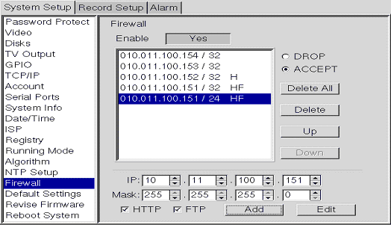

Rule table

DROP / ACCEPT
Default to rule table can be selected as DROP or ACCEPT. If default is DROP, that means rules in Rule table are accepted and all others are rejected. On the contrary, If default is ACCEPT, that means rules in Rule table are rejected and all others are accepted。

Add / Edit
Adding or edit an IP address. “mask” means domain address. For example, when key in IP:10.11.100.151，Mask:255.255.255.0，this means IP address from 10.11.100.1 to 10.11.100.255 will be blocked，totally 255 IP addresses。
HTTP: When default is DROP and HTTP is NOT checked, this means the HTTP port of this IP is rejected. On the contrary，if default is ACCEPT and HTTP is NOT checked，that means the HTTP port of this IP address is opened。
FTP: Same as HTTP。

Rule table
Rules in the table are checked by top down sequence. When any one of the rule is satisfied, checking will NOT go down.
For Example:
Default Rule ACCEPT
1. 10.11.100.151/24 HF (means IP coming from 10.11.100.* are all rejected.)
2.10.11.100.154/32 (means ports from 10.11.100.154 are all rejected EXCEPT HTTP and FTP )
If you use 10.11.100.154 to access VPON DVR web page, it will fail.

When the sequence of Rule1, Rule2 are exchanged and Default Rule is ACCEPT
1.10.11.100.154/32
2. 10.11.100.151/24 HF
Then, if you use 10.11.100.154 to access VPON DVR web page，it will work OK.

Delete
Delete a specific rule in Rule table.

Delete All
Delete all rules in Rule table.

Up
Move a specific Rule one row up

Down
Move a specific rule one row down

3.7.20 Network Neighbor
User can copy the recorded files of VP-4104R (H) / VP-4148R(H) to other PC through network neighbor.
1. Enable the Network Neighbor function.
- After define the server name, workgroup and WINS server, user can find out the DVR recording files from Microsoft windows network neighbor.
Note: when you setup server name and workgroup, please key-in English characters or numbers only.

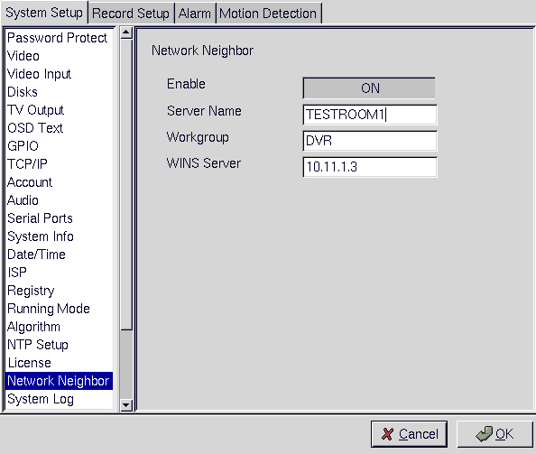

3.7.21 Default settings
Use the Default Settings menu to reset all configurable parameters to their factory default settings.
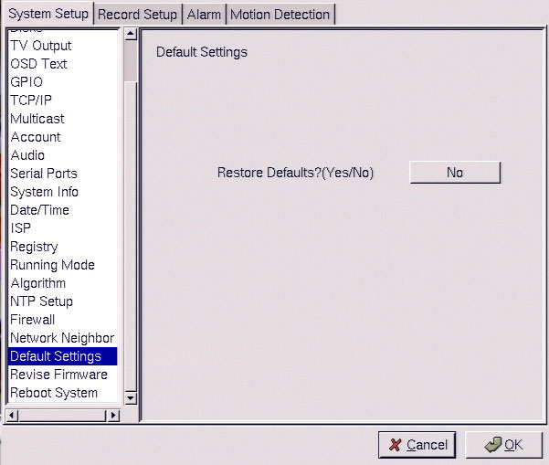
Click Restore Defaults?(Yes/No) to restore defaults. Click Cancel or No to retain the current settings.

3.7.22 Revise firmware
Use the Revise Firmware menu to upgrade the VPON DVR firmware.

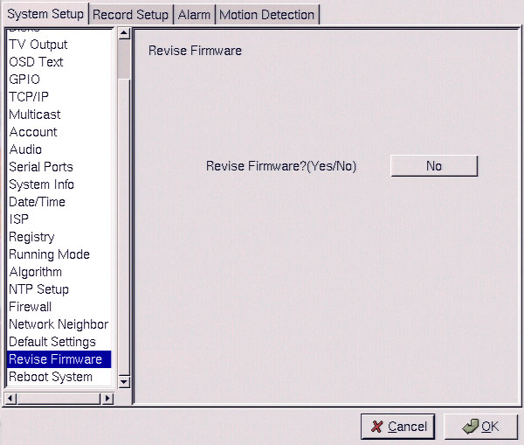
Click Revise Firmware?(Yes/No) to start the firmware upgrade process. Click Cancel or No to abort the attempt.

3.7.23 Reboot system
Use the Reboot System menu to reboot or shutdown the system.
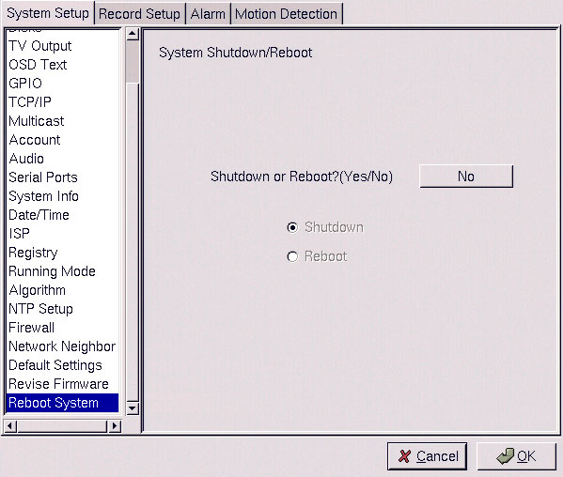
Use the keyboard or mouse (recommended) to select either Shutdown or Reboot. Click OK to perform the operation. Click Cancel or No to abandon.

[Record Setup]

3.8.1 DVR setup
Use the DVR menu under the Record Setup tab to set the Digital Video Recorder parameters.

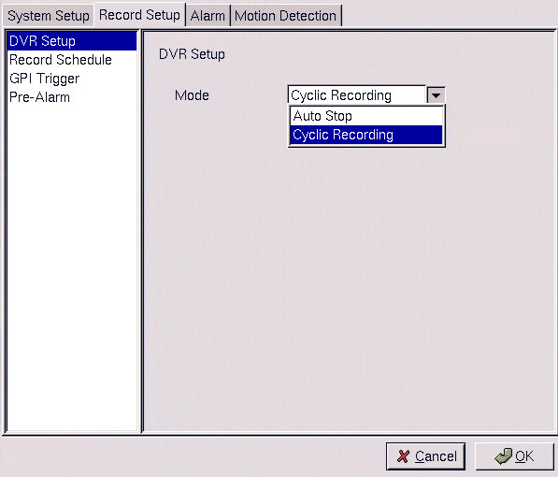
Select either Auto Stop or Cyclic Recording. Auto Stop recording stops when disk space runs out. Cyclic Recording continues to record until disk space runs out and then overwrites the oldest records. Click OK to save changes.

3.8.2 Record schedule
Use the Record Schedule menu under the Record Setup tab to set up automatic recording schedules for each camera and audio. You can set up to 16 record schedules that automatically record at given times and days even frame rate just remember to close auto speed setting. Weighted recording is setting special recording frame rate when an alarm of one of camera was triggered.
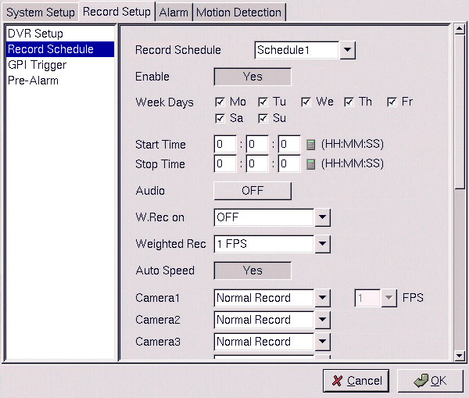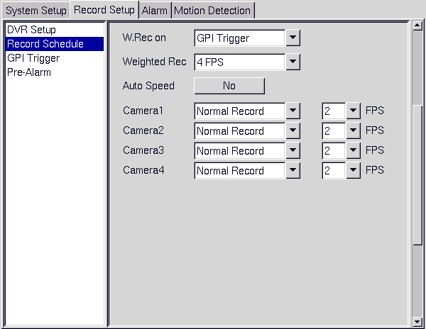
Use the keyboard or mouse (recommended) to complete all fields and click OK to save changes.

3.8.3 GPI Trigger
Use the GPI Trigger menu under the Record Setup tab to enable recording video from specified cameras when triggered by an internal alarm (GPI) connected to the system. For instance, you may want to record video from a camera installed at your front door when the door lock is opened. In this case, connected an alarm module (not provided ) to lock and set the front door camera to start recording.
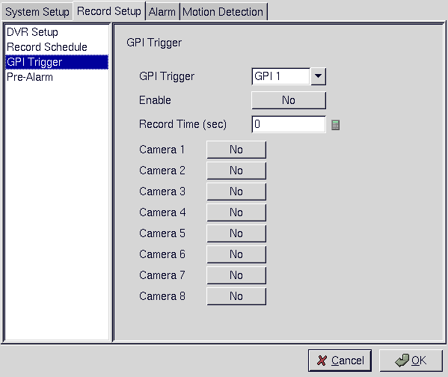

3.8.4 Pre-alarm recording
Use the pre-alarm menu under the record setup tab to determine how many frames are record before an alarm event occurs. Each camera can be set separately and you can record up to 300 frames.
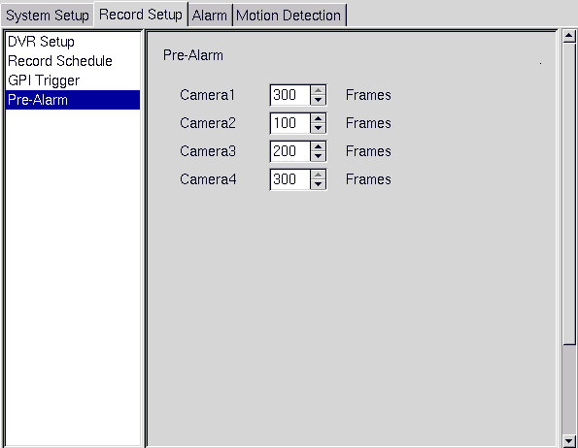

[Alarm]

3.9.1 Alarm setup
Use the Alarm Setup menu under the Alarm tab to define what action is taken when an alarm is triggered. Through this menu, you can set up an E-mail address to which an E-mail is sent when the alarm is generated, or set up the device to display a video popup message on your monitor.

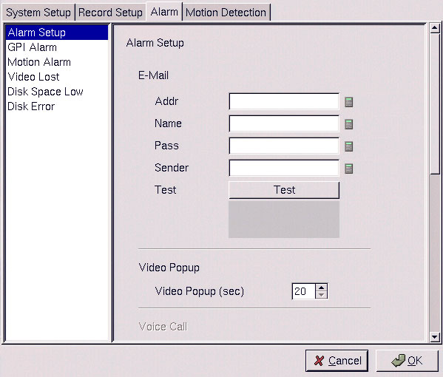

Note: The voice call function is not supported.

3.9.2 GPI Alarm
Use the GPI Alarm menu under the Alarm tab to set what actions are taken when a GPI alarm is generated. You can set up the alarm through a message, a beep, a video popup, or E-mail.
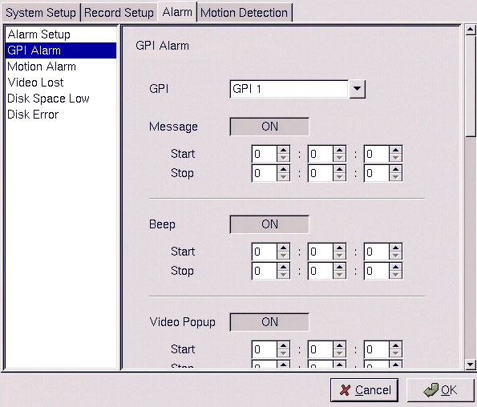
Use the keyboard or mouse (recommended) to select the required GPI from the GPI drop-down box and complete all fields. For each action, you can specify the time interval over which the GPI is monitored for an alarm to be generated. For the E-mail option, specify the recipient, subject, and text of the E-mail along with which of the cameras.” status” is sent in the E-mail and the start and stop times. Click OK to save changes.

3.9.3 Motion Alarm
Use the Motion Alarm menu under the Alarm tab to set what actions are taken when a motion detection alarm is generated. You can set up the alarm through a message, a beep, a video popup or E-mail.

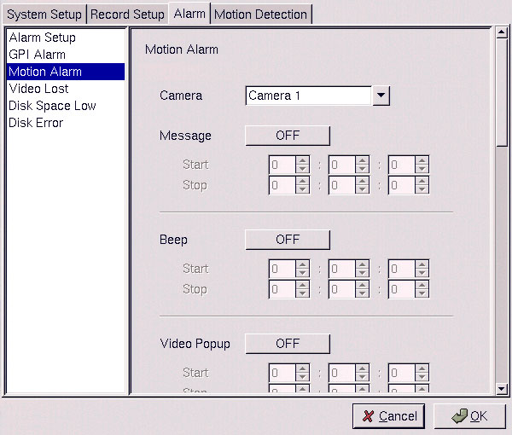

3.9.4 Video lost
Use the Video Lost menu under the Alarm tab to set what actions are taken when video signal from a camera is not available. You can set up the alarm through a message, a beep, a video popup or E-mail.
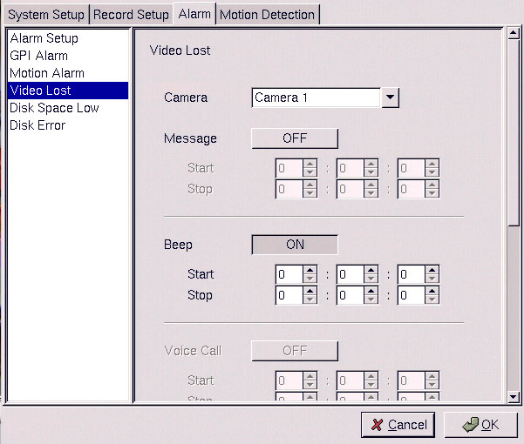
Use the keyboard or mouse (recommended) to select the required camera for video lost from the Camera drop-down box and complete all fields as described in GPI alarm. Click OK to save changes.

3.9.5 Disk space low
Use the Disk Space Low menu under the Alarm tab to set what actions are taken when the disk space is insufficient to record data. This alarm is generated only when the DVR mode is set to Auto Stop. You can set up the alarm through a message, beep, video popup, or E-mail.

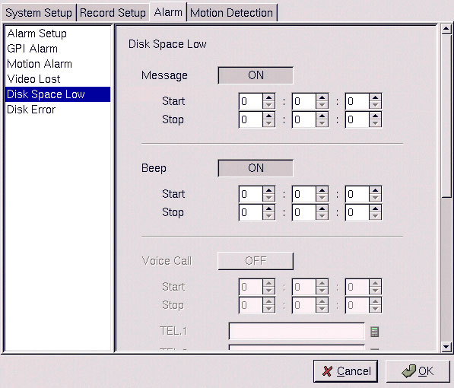
Use the keyboard or mouse (recommended) to complete all fields as described in GPI alarm. Click OK to save changes.

3.9.6 Disk error
Use the Disk Error menu under the Alarm tab to set what actions are taken when there is an error while accessing the disk. You can set up the alarm through a message, a beep, a video popup, or E-mail.
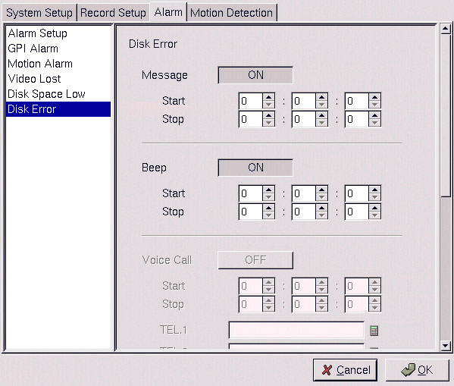
Use the keyboard or mouse (recommended) to complete all fields as described in GPI alarm. Click OK to save changes.

3.10 Motion Detection
Use the Motion Detection page to set motion detection parameters for each camera.
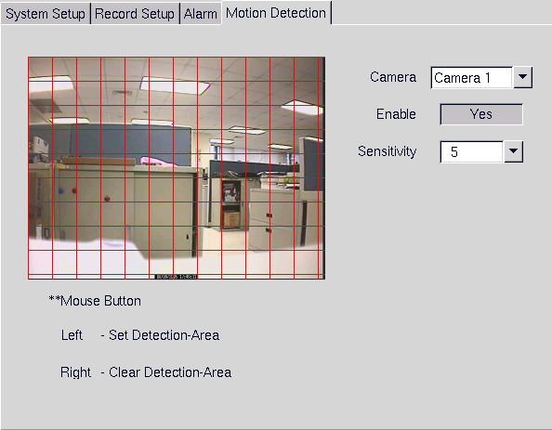
Each small square on the displayed grid can be set to detect motion. Use the left mouse button to make a square sensitive to motion. Use the right mouse button to make it insensitive. Click OK to save changes.

