F/W 1.4.3A RELEASE NOTE
Joseph Kuo 2009/10/05
[Information Note]
Filename: system.bin.en.143A / system.bin tc.143A
Author : Wesly
FW Version: 1.4.3A
Date: Sep 24 2009 14:23:32
Driver Version: 1.1.22
Kernel Version 2.4.31
DCS Version: 2.09C
Beta or Release: Release
Inherited from which FW Version: F/W 1.43

[NEW FEATURES]
- [Remote] Remote Playback functionality is improved. Calendar added. Easier to search and playback.
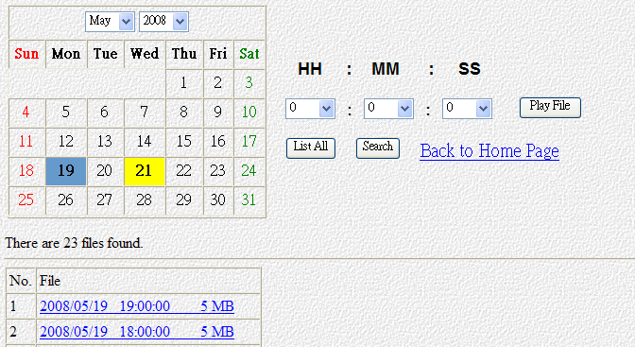
- [Remote/Local] New POS functions added：
  - 4/9/16 split screen can display POS Text.
  - Trans. Start and Trans. End allow us to identify the beginning and the end of each transaction, so that each result of the search is one transaction.
  - Search Text1 and &Text2 and &Text3: It can search 3 strings of text at a time. In other words, the transaction must contain the 3 strings.
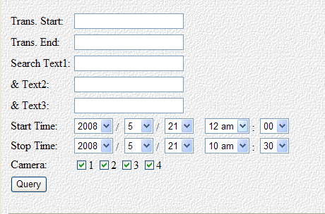
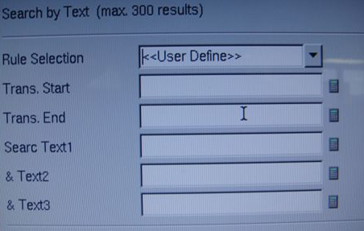
  - POS Text Color added.
  - POS Text Position added (4 positions in single-split screen).
  - Can choose the POS Text Background color (applicable in 1, 4-split screen).
  - Configurable Time to clean the POS text when there are no new POS texts (maximum 3600 seconds).
- [Local] In the presence of low signal or no signal at all, the image will be replaced with an image of "No Video". The DVR will also record this image.
- [Local] In motion detection, we added the selectable function of "Noise Rejection".
- Improved playback loading speed.
  - [Local]The playback will load one channel in pause mode by default instead of 16 channels.
  - [Remote] When the playback list webpage loads up, we deactivated the automatic "List All". The user has to select a date from the calendar.
- [Remote] In the usyscfg.htm webpage, we added the option to choose the type of TVOUT:
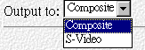
- The default value of the Registry Server is blank.

[BUG FIXED]
- [Local] In the OSD Mode, fixed the bug that made the selecting windows of the backup disappear.
- Fixed the bug that would stop recording when the signal is too low or too noisy (it will try to restart the video chip).
- [Local] Backup using the USB device will not fail anymore.
- FTP upload function will still work even after a reboot.
- The Start time & Stop time of the FTP upload Continuous Mode is working correctly.
- Changing the TimeZone will now save correctly and make a reboot.
- Restoring configuration file will now include TVOUT settings and Timezone settings.
- Disabled the Audio loop back function in single split screen, since it would create conflict with the two-way audio function.
- Fixed: When the Event recording and Pre-Alarm function is enabled, the recording won't have any "ghost" or residual images.

[IMPORTANT NOTE]
- FW1.4.3A is suitable for VP40, VP42 cards.
- FW1.4.3A is only for DOM with a size bigger or equal to 128MB.
- FW1.4.3 is restricted to mouse with wheel button, it doesn’t support the old-style mouse (2 button mouse).
- The priority of selecting the GPIO device is: Serial Port Device > VP-MB945G GPIO > GPIO Card.
- FW1.4.3A VP42 Audio input must require externally powered microphones.
- MPEG4 recorded files doesn't support Step Backwards.
- The POS text in single-split screen is restricted to 29 characters per line.
- Firmware Filename: Firmware Size: Firmware date:
system.bin.en.143A 53,111KB 2009/10/05 PM 11:08
system.bin.tc.143A 53,115KB 2009/10/05 PM 11:09

- DCS Files：
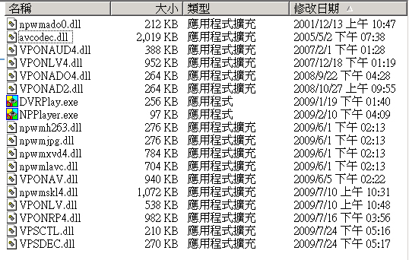

[KNOWN PROBLEM]
- [Remote] POS Text color / Background/ Position and Pos Clean Time can't be configured.
- The sound test of ASUS P5PL2 will cause the acute beeping.
- [Local]When playing back file in OSD mode, Channel 1 and 5 has pos transaction data on the 16 split screen. If user changes to the single screen, the pos transaction data will still show on the screen.
- [Remote] During the Playback, the time selected and the timestamp may have minor differences.
- The FTP upload triggered by motion detection will load images with a 10 second delay ( the trigger object already left the image).
- [Local] "Video Lost" message will leave "ghost" or residual text.
- [Local] The system will reboot when the resolution is changed from 320*240 to 640*480. The reboot problem will not happened if you install four vp416 cards. It is happened when only installing one 404R card. After rebooting, the configuration is still revised successfully.
- When enable the POS function of VP204-1, it will interrupt the connection of VP204-1 after setting the POS event.
- The video is not refreshed when monitoring the live video from web page by using PDA.
- The end date of Daylight Saving Time in London is not correct.
- When setting the date to 2007/10/28 on the local side, the timestamp of the files in ftp will show the date as 2006/10/28 if you change the time area to London.
- When setting the GPI Trigger Recording function, we suggested for one camera, select normal recording to avoid the recorded data too few and playback may cause system error.
[SYSTEM REQUIREMENTS]
CPU：Celeron 3.06G or better.
RAM: 512MB or higher.
LAN card：Ethernet 100Mbps or better.

