Appendix : Guide to Revise Firmware of DVR(For 32MB DOM only)

When the user uses 32MB DOM, user can revise to the FW1.4 version , please step-by-step instructions for revising/upgrading firmware of the DVR. If user use above 128MB DOM not to do this step.

- Use revise.htm
- If you want to download and update the system firmware, please check with your distributor to verify eligibility.
- Open Windows Internet Explorer and type in your DVR IP address like this:
“http://DVR IP/revise.htm”

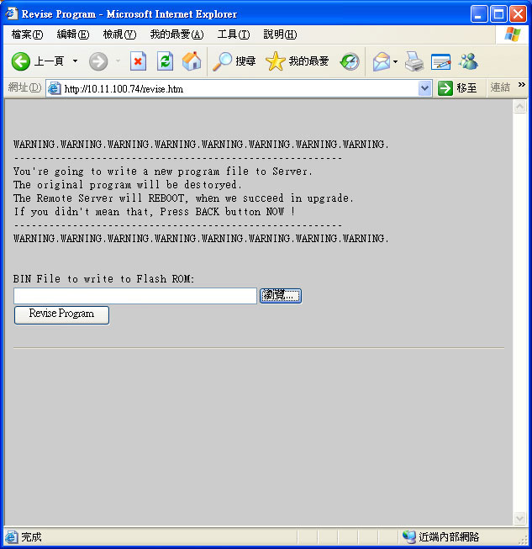

3. Before revision of system.bin to DVR, be sure to revise with "system.bin.en.1x_32mb_patch", this patch can be used to ensure the success of revision of FW1.4

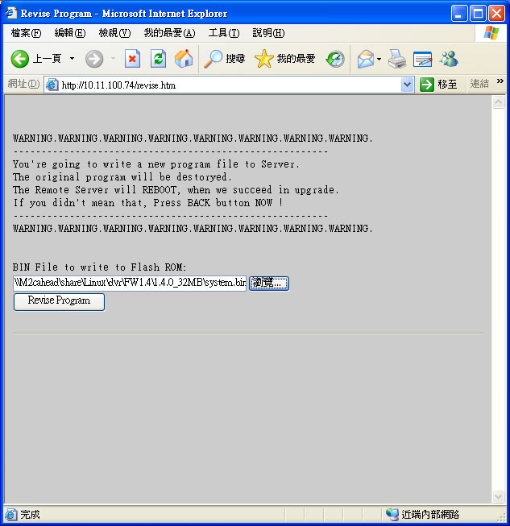
Step 1
Step 2
Step 3

- Before revision of system.bin to DVR , please make sure of the version , while name should include (STD).

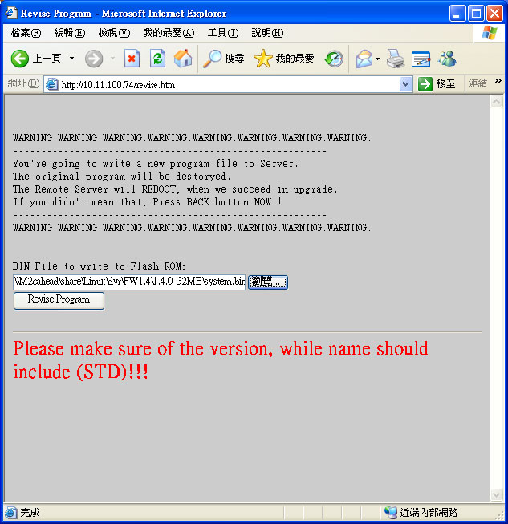

- Browse for the saved copy of the updated firmware and click revise program then start to the update process.

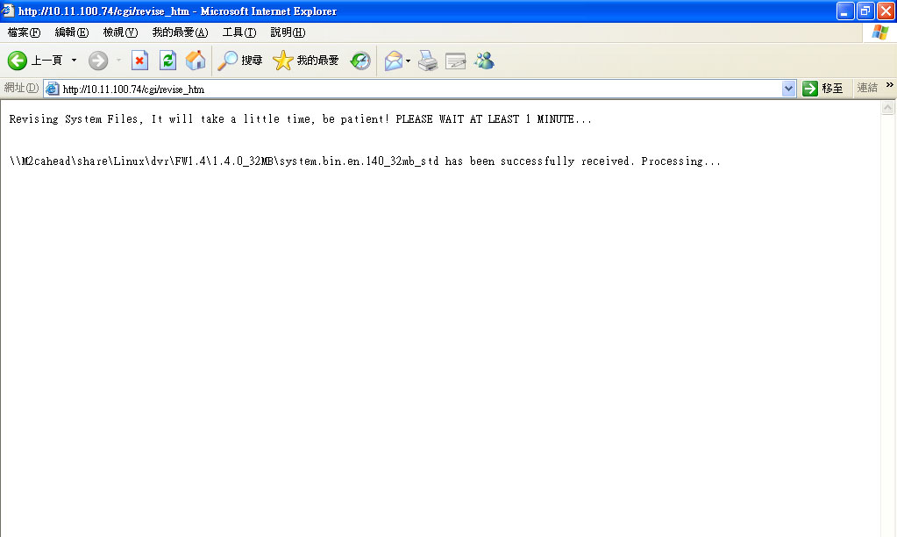

- The DVR will reboot automatically after the revision is complete.

Note: User can not restore original firmware after revise the FW1.4 version.please note.

