4CH MJPEG DVR

USER MANUAL

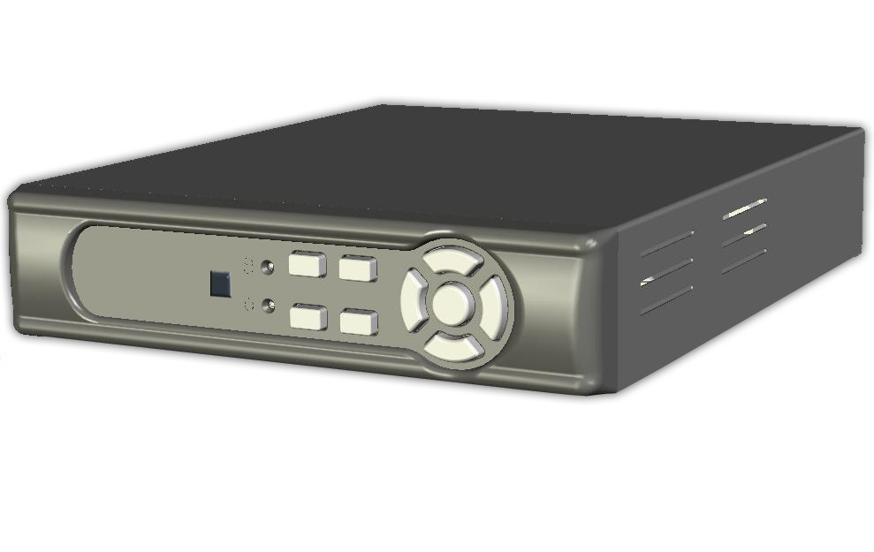

Content

1. SAFETY PRECAUTIONS 3
2. INTRODUCTION 4
2.1 Product Introduction 4
2.2 Application 4
3. FEATURES 5
4. PACKING LIST 6
5. INSTALLATION 7
6. NAME and FUNCTION of EACH PART 8
6.1 Front Panel 8
6.2 Rear Panel 9
7. OPERATING PROCEDURE 10
7.1 Power On 10
7.2 Monitoring Mode 10
7.3 Record Mode 11
7.4 Playback Mode 12
8. SYSTEM SETUP 13
8.1 Menu 13
8.2 System Setup 14
8.2.1 Time Setup 15
8.2.2 Password Setup 16
8.2.2.1 Change Password 17
8.2.3 Load Default 18
8.2.4 R/C CHECK ID 19
8.3 Camera Setup 20
8.3.1 Camera Setup 21
8.4 Record Setup 23
8.4.1 RECORD MODE 24
8.5 Buzzer Setup 26
8.6 Event List 28
8.6.1 TIME SEARCH 29
8.6.2 EVENT SEARCH 30
8.7 USB SETUP 31
8.7.1 TIME SETUP 32
8.7.1.1 COPY 33
8.7.2 FORMAT / ERASE 34
8.8 Hard Drive Setup 35
8.8.1 FORMAT/ ERASE 36
9. REMOTE CONTROL 37

10. NETWORK REMOTE CONTROL (Optional) 38
10.1 Network DVR Setup 38
10.1.1 Online with DHCP Server 38
10.1.2 Online without DHCP Server 39
10.2 Connecting Network DVR 39
10.2.1 Online using Intranet or Fixed IP 40
10.2.2 Online using ADSL (PPPoE) Router 40
10.2.3 Online using DDNS Server 40
10.2.4 Online Connection 40
10.2.4.1 Install ActiveX 41
10.3 Main Display 44
10.3.1 Live Display 44
10.3.2 View 45
10.3.3 Rotate 45
10.3.4 Image Recording 45
10.3.5 Save Current Picture 46
10.3.6 DVR Control Setup 46
10.3.7 Quality Setting 46
10.3.8 Resolution Setting 47
10.3.9 Advance Settings 47
10.4. Configuration 47
10.4.1 System Setting 47
10.4.2 User Setting 48
10.4.2.1 User Authorization Setting 48
10.4.2.2 New user/ Change Password 49
10.4.2.3 Delete User 49
10.4.3 Network Setting 49
10.4.3.1 Fixed IP 49
10.4.3.2 DHCP 50
10.4.3.3 Connect to ADSL by PPPoE mode 50
10.4.4 DDNS Setting 51
10.4.5 Firmware Update 53
11. HDD Player Software Description 55
12. TROUBLESHOOTING 61
13. SPECIFICATIONS 62

The author assumes no responsibility for any errors or omissions that may appear in this document nor does it make a commitment to update the information herein.

VER.: 4.0, CD

1. SAFETY PRECAUTIONS
It is advised to read the Safety Precaution Guide through carefully before operating the product, to prevent any possible danger.
WARNING: This symbol is intended to alert the user to the presence of un-insulated “ dangerous voltage”.

CAUTION: This symbol is intended to alert the user to presence of important operating and maintenance (Servicing) instructions in the literature accompanying the appliance.


Disposal of Old Electrical & Electronic Equipment (Applicable in the European Union and other European countries with separate collection systems).
This symbol on the product or on its packaging indicates that this product shall not be treated as household waste. Instead it shall be handed over to the applicable collection point for the recycling of electrical and electronic equipment. By ensuring this product is disposed of correctly, you will help prevent potential negative consequences for the environment and human health, which could otherwise be caused by inappropriate waste handling of this product. The recycling of materials will help to conserve natural resources. For more detailed information about recycling of this product, please contact your local city office, your household waste disposal service or the shop where you purchased the product.
The power cord is the main power connection. Therefore, constantly plug and unplug of the power cord might result in malfunction of the product.

Do not install the product in an environment where the humidity is high.
Unless the product is waterproof or weatherproof, otherwise it can cause the image quality to be poor..
Do not drop the product or subject them to physical shocks.
Except for vandal-proof or shockproof product. Otherwise it will result malfunctions to occur.
Never keep the product to direct strong light.
It can damage the product.
Do not spill liquid of any kind on the product.
If it gets wet, wipe it dry immediately. Alcohol or beverage can contain minerals that corrode the electronic components.
Do not expose to extreme temperatures.
Use the product at temperatures within 5℃ ~ 40℃.

2. INTRODUCTION

2.1 Product Introduction
The product is perfect for office safety, personnel home security, public environments, industry surveillance, school, and so on. Quick and simple installation is the best choice for your own ultimate protection.
The sate-of-art 4-channel M-JPEG Network (optional) digital video recording, enables monitoring simply through internet. Replaces the old conventional video recorders and supports Chinese user interface. Using time and event to playback recorded materials, efficient live recording and playback function, supports ATA hard disk and network transmission, and enables network remote control. The administrator can freely setup administrator password to prevent any user randomly changing the setup.

2.2 Application
- Security:
ATM (auto teller machine), bank, gas station, shop and parking lot.
- Factory/ Office:
Factory, warehouse, remote technology support, conference room, and outdoor parking lot.
- Education/ Military/ Government Organization:
Important facilities, important areas, rapid transit system, and railroad safety.
- Recreation/ Activities:
Sports and news broadcast.
- Home:
Elevator, doorway, community safety, and hotels.
- Hospital/ Kindergarten:
Hospital and isolated ward, home for the aged, kindergarten, and baby nourishing center.

3. FEATURES

- Video system auto detection
Auto detects video input (NTSC/ PAL) and supports combine use of color and b/w cameras.
- Supports high quality digital video recording
Adopts M-JPEG compression technology (NTSC: 30fps/ PAL: 25fps).
- Video Size

Video Resolution
• NTSC: 640x 224
• PAL: 640x 272
Monitoring Resolution
• NTSC: 720x 480
• PAL: 720x 576
- Replaces the conventional VCR.
Stores video on hard disks instead of VCR tapes, with large disk capacity, there is no need to replace the recording medium.
- Built-in motion detection function.
Motion detection sensitivity rate may be setup under motion detection function.
- High efficient event recording, saving storage capacity.
Motion detection function enables recording only when system detects motion, thus increases the amount of time available for recording.
- Easy access to the desired record.
Time & date search supports instant retrieval of images and alarm event search
makes searching simpler.
- Live monitoring through internet from anywhere (optional).
Built-in TCP/ IP network interface (auto detects and switches to 10/ 100Base T).

4. PACKING LIST
Check to make sure all of the items shown below are included in your product package. If something is missing, contact your dealer as soon as possible.

Item Description | Item Picture | qty
DVR |  | 1
DC 12V/2A Power Adaptor or above  Input: AC 100~240V  Output: DC 12V/ 2A or above | 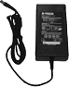 | 1
Power Cord |  | 1
User Manual | 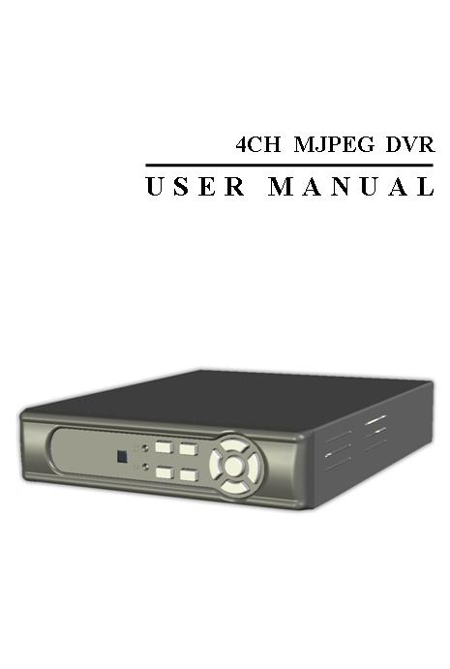 | 1
Quick Guide | 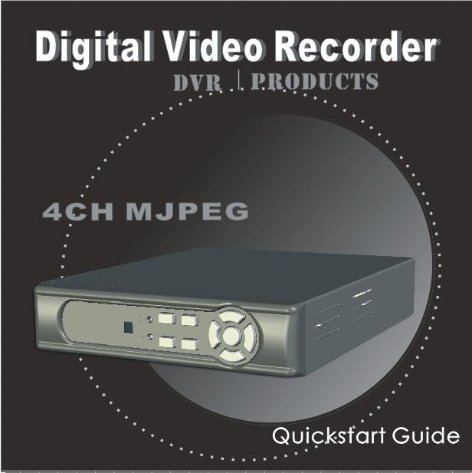 | 1
Remote Control (option) |  | 1

5. INSTALLATION
Connectors on the Rear Panel
Please setup the connection by following the illustration shown below (network is an optional function):
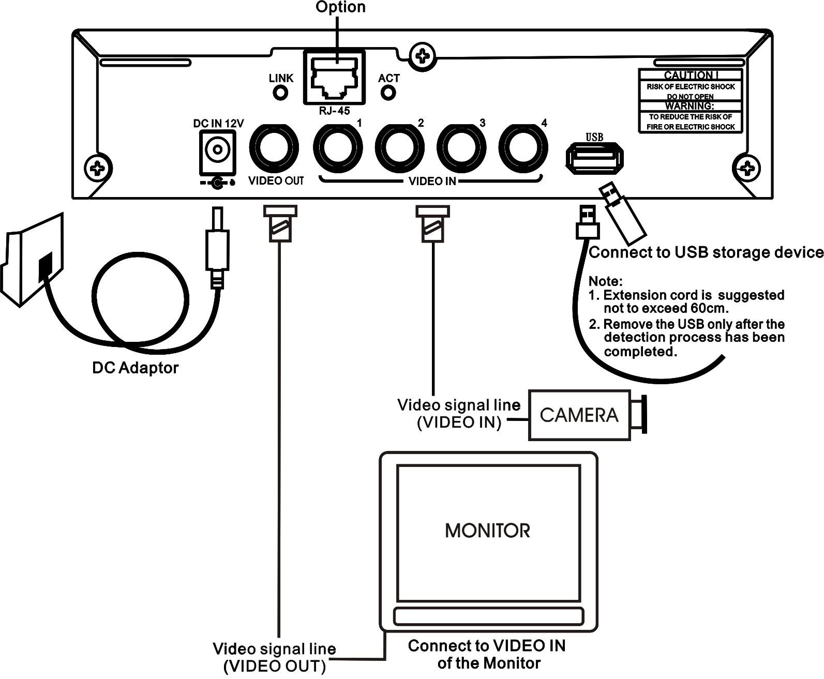

6. NAME and FUNCTION of EACH PART

6.1 Front Panel
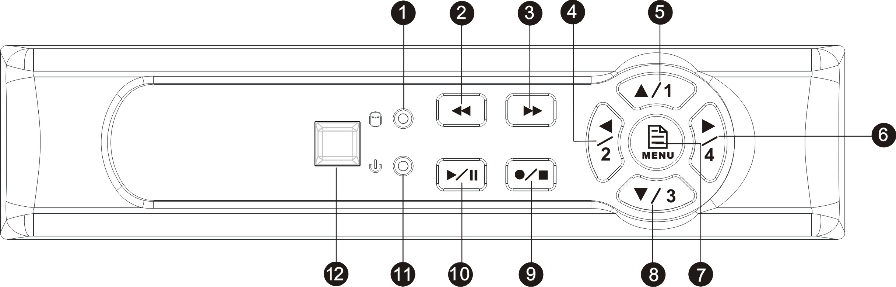

- : Record LED indicator.
- : Rewind button.
- : Fast forward button.
- : Left direction button / CH 2 screen display / Number button 2
- : Up direction button / CH 1 screen display / Number button 1
- : Right direction button / Enter Selection/ CH 4 screen display / Number button 4
- : Enter / Exit Menu
- : Down direction button / CH 3 screen display / Number button 3
- : Record / Stop button
- : Play / Pause button
- : Power LED indicator
- : Remote Control Receiver

6.2 Rear Panel

- RJ45: Internet connection terminal.
- USB: Connect to external USB storage device (Plug and Play).
- Video Input [VIDEO IN]: Connect to cameras.
- Video Output [VIDEO OUT]: Connect to the monitor.
- DC 12V [Power Input terminal]: power socket.

7. OPERATING PROCEDURE

7.1 Power On
After power on, DVR will auto-detect its peripherals (self-testing, auto detects the hard disk, and etc.)
The system will detect the video input and judge whether the video system is NTSC or PAL. When video input is unable to be detected (VIDEO LOSS), the system will send out an alarm, press any button to stop the alarm (it will not affect the actual recording, but when all (1CH-4CH) video images disappears, the DVR will stop recording).

7.2 Monitoring Mode
This mode is a default for our system after power on. Under this mode, system supports live view for monitoring. Pressbutton, the system enters the record mode, pressbutton to start playback, pressbutton to enter the menu setup display.

During playback, pressbutton to return to monitoring mode. Pressto change the speed (FF1, FF2 or FF3), or pressbutton to start reverse playback.

- To reset (under quad or single display), press《►》button 5 times, the message《ALL SETTING DATA IS INITIALIZED.》 will be displayed by flashing 3 times, and after reset the password will be set as default value (423113).
- When reset procedure has been completed, the message“DVR RESET COMPLETED. TURN OFF AND ON THE DVR”will be displayed, then please restart the DVR.

7.3 Record Mode
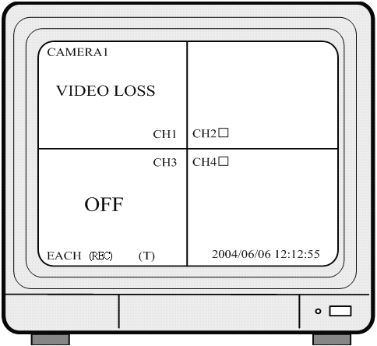

Note:CH1: No block figure next to CH1 indicates that it is not recording.
EACH: Record Type QUAD: Record Type
(T): TIMER RECORD (A): MOTION RECORD (M): MIX RECORD
(□): Currently under recording.
VIDEO LOSS: Video input unable to be detected.
CAMERA1: Title for CH 1.
OFF: Channel is set to “OFF”.

7.4 Playback Mode
TIME SEARCH

03/11/27 18:20:42 - 03/11/27 19:32:32

>01 TIME 2003/11/27 18:20:42
02 TIME 2003/11/27 16:43:56
03 TIME 2003/11/27 15:07:11

(▲▼) MOVE (►)CHANGE (PLAY)PLAY
(MENU) EXIT (FF)SELECT EVENT OR TIME

>01 TIME
Total 7
>07

  - First press《STOP》button to stop record, then press《PLAY》button to enter search display.
  - Press 《FAST FORWARD》button, then《PLAY》button to playback data from old to new. Use up and down 《▲/▼》 button to move the cursor to the desired playback time, press《▲/▼》button to start playback.
  - When wish to view recorded videos of a specific time, use up/ down/ left/ right button and《►》button to make changes.
  - During playback press《PAUSE》button to pause and press again to playback.
  - Press《FAST FORWARD》button to fast forward playback and《REWIND》to rewind.
  - Press《STOP》button to stop playback.

8. SYSTEM SETUP

8.1 Menu
(2)
（1）
(3) > SYSTEM SETUP
CAMERA SETUP
RECORD SETUP
BUZZER SETUP
EVENT LIST
USB DEVICE SETTING
HARD DRIVE SETUP
(4) PRESS (▲▼), THEN (►)
PRESS (MENU) TO EXIT

    - MAIN MENU: Item subject (First menu layer does not have a subject).

    - Menu Layer Indication: The device consists of four menu layers.
■ | ：First Menu Layer (Main Menu)
■■ | ：Second Menu Layer
■■■ | ：Third Menu Layer
■■■■ | ：Fourth Menu Layer

(3) Menu Operation and Setup
Press《▲》or《▼》button to move the cursor ( > ).
Press《►》button enter the sub menu.
Press《MENU》button:
- Under second or third menu layer, the system will return to the previous menu layer (second layer to first layer or third layer to second layer) and auto updates the modified data.
- Under main menu (first menu layer), the system will enter live mode.
Press《►》button, to increase or decrease the setting values that has been highlighted.

(4) Menu Layer Operation Guide

8.2 System Setup

SYSTEM SETUP ■■

> TIME SETUP
PASSWORD SETUP
LOARD DEFAULT
LANGUAGE SETUP ENGLISH
R/C CHECK ID ALL
VERSION V1.4

PRESS(▲▼), THEN (►)
PRESS (MENU) TO EXIT

  - Cursor (>) position indicates the current function selected.
  - Press《▲》and《▼》button to move the cursor.
  - Press《►》button to proceed.
  - Press《MENU》button to exit “System Setup”.
  - “System Setup”is situated on the second menu layer. Under this menu layer user may setup the system time, password, return system to default value, and language preference, etc (VERSION displayed represents the FIRMWARE version).

8.2.1 Time Setup
TIME SETUP ■■■

2005/01/11 17：23：06
^

PRESS (▲▼), THEN (►)
PRESS (MENU) TO EXIT

  - Cursor (^) position indicates the current time and date selected.
  - Use《▲》or《▼》button to move the cursor.
  - Use《►》button to setup time and date.
  - Use《MENU》button to exit “Time Setup”.

8.2.2 Password Setup
PASSWORD SETUP ■■■

> | PASSWORD CHANGE
 | MENU PASSWORD | OFF
 | STOP REC PASSWORD | OFF

PRESS (▲▼), THEN (►)
PRESS (MENU) TO EXIT

  - Cursor (>) position indicates the current function selected.
  - Use《▲》and《▼》button to move the cursor to the desired item .
  - Use《►》button to make changes.
  - Use《MENU》button to exit “Password Setup”.
  - When the password is setup to “ON”, user will be requested to enter the correct password for entering from live display to menu selection (Default Password: 111111).
  - When the password is setup to “ON”, user will be requested to enter the correct password to stop recording (Default Password: 111111).

※ When incorrect password has been entered, “PASSWORD INCORRECT”will be shown on the display. To disable the message, press button: QUAD, CH1, CH2, CH3, or CH4.

8.2.2.1 Change Password
■■■■

CURRENT PASSWORD ：_ _ _ _ _ _

NEW PASSWORD ：_ _ _ _ _ _

CONFIRM PASSWORD ：_ _ _ _ _ _

PRESS (MENU) TO EXIT

  - Press《►》button to show the display above.
  - Enter the current password (CURRENT PASSWORD).
  - Enter new password (NEW PASSWORD).
  - Confirm the new password (CONFIRM PASSWORD).
  - When password change is successful, the system will display “PASSWORD CHANGED”.

- Default Value: 111111
If password entered is incorrect, you will receive a message “NO PASSWORD CHANGED” to inform you (message flashes three times) and the system returns to “Password setup” selection.

- All buttons may be used as a password during password setup, except for the MENU button.

8.2.3 Load Default
LOAD DEFAULT ■■■

PRESS (►) TO RESET

PRESS (MENU) TO EXIT

  - Press《►》button to show the display above.
  - Press《►》button the message《ALL SETTING DATA IS INITIALIZED》 will be displayed by flashing 3 times, and returns to default value. When reset procedure has been completed, the message“DVR RESET COMPLETED TURN OFF AND ON THE DVR”will be displayed, please restart the DVR.
  - Press《MENU》button to exit “Load Default Setup” selection.

8.2.4 R/C CHECK ID
SYSTEM SETUP ■■

TIME SETUP
PASSWORD SETUP
LOARD DEFAULT
LANGUAGE SETUP ENGLISH
> R/C CHECK ID ALL
VERSION V1.4

PRESS(▲▼), THEN (►)
PRESS (MENU) TO EXIT

  - Cursor (>) position indicates the current function selected.
  - Press《▲》and《▼》button to move the cursor.
  - Press《►》button to proceed.
  - Press《MENU》button to exit “System Setup”.

- Remote control ID consists of 10 sets of the numbers: ALL, 11, 12, 13, 21, 22, 23, 31, 32, 33.

Select “ALL” (setup is only effective if you return to LIVE mode after the setup) and user may control any DVR using the remote control.

Select one of the numbers (e.g. 11) and setup as remote control ID, then press the setup remote control ID number (11) on the remote control and when the message “REMOTE CONTROL SET” (Fig. 1) appears indicates that setup is successful. When incorrect remote control ID number has been entered, a message “R/C ID IS NOT CORRECT” (Fig. 2) appears. Please repeat the setup until the message “REMOTE CONTROL SET” appears.

- After R/C CHECK ID setup, you must return to Live monitoring mode because it is only effective if you return to LIVE mode after the setup.

8.3 Camera Setup
CAMERA SETUP ■■

> CAMERA ENABLE 1234
CAMERA TITLE ----
CAMERA SETTING
CH1 TITLE CAMERA1
CH2 TITLE CAMERA2
CH3 TITLE CAMERA3
CH4 TITLE CAMERA4

PRESS (▲▼), THEN (►)
PRESS (MENU) TO EXIT

  - Cursor (>) position indicates the current function selected.
  - Press《▲》and《▼》button to move the cursor.
  - Press《►》button to proceed.
  - Press《MENU》button to exit.
  - “Camera Setup” is situated on the second menu layer. Under this menu layer user may setup camera title (camera title for CH1, CH2, CH3 and CH4), standard camera setup, etc.
  - Press《▲》or《▼》button to move up and down and《►》button to change the camera view combination (select to view the desired channel).
(It consists of 16 different optional camera view combinations)
1) Select (- - - -), all cameras are disabled (no image display).
2) Select (1 2 3 4), all cameras are operational (quad image display).
3) Select (- - - 4), only camera four is operational (CH4 image display only).

- When proceeding “CH1 TITLE”, press《►》button to show the display below:
V
CH1 TITLE CAMERA1
12345678
“V” indicates the position of the cursor. Press《▲》or《▼》button to move the cursor, and press《►》button to change the title (maximum 8 characters).
- All channel titles are setup in the same way.

Once the user formats the hard disk drive, the camera title returns to its default setting (CAMERA1/ CAMERA2/ CAMERA3/ CAMERA4). It is because this setup is stored in the hard disk drive.

8.3.1 Camera Setup
CAMERA SETTING ■■■

> | CAMERA SELECT | CH1
 | RECORD ENABLE | ON
 | MOTION DETECTION | ON
 | MOTION SENSITIVITY | 03
 | HUE | 08
 | CONTRAST | 08
 | BRIGHTNESS | 08

PRESS (▲▼), THEN (►)
PRESS (MENU) TO EXIT

  - Cursor (>) position indicates the current function selected.
  - Press《▲》and《▼》button to move the cursor to the desired item.
  - Press《►》button to make changes.
  - Press《MENU》button to exit “CAMERA SETUP” selection.
  - CAMERA SELECT: Press《►》button to select the desired channel.
  - RECORD ENABLE: Press《►》 button to switch the channel recording ON/ OFF.
  - MOTION DETECTION: Press《►》button to switch the motion detection function ON/ OFF.
  - MOTION SENSITIVITY: Press《►》button to setup the motion sensitivity rate (5 sensitivity rate values, 01 most sensitive).
  - HUE: Press《ENTER》button to adjust the color of cameras (15 color adjustment values, default value: 08).
  - CONTRAST: Press《►》button to adjust the camera contrast (15 contrast adjustment values, default value: 08).
  - BRIGHTNESS: Press《►》button to adjust camera brightness (15 color adjustment values, default value: 08).

8.4 Record Setup
RECORD SETUP ■■

> | RECORD TYPE | EACH
 | VIDEO QUALITY | NORMAL
 | TIME RECORD FRAMERATE | 04
 | MOTION RECORD FRAMERATE | 15
 | MOTION REC TIME | 10
 | RECORD MODE

PRESS (▲▼), THEN (►)
PRESS (MENU) TO EXIT

  - Cursor (>) position indicates the current function selected.
  - Use《▲》and《▼》button to move the cursor to the desired item.
  - Use《►》button to make changes.
  - Use《MENU》button to exit “RECORD SETUP” selection.
  - “Record Setup” is situated on the second menu layer. Under this selection user may setup the following function: Record Type, Video Quality, Time Record Frame rate, Motion Record Frame rate, Motion Record Time, and Record Mode.
  - RECORD TYPE: Press《►》button to select between “QUAD” and “EACH” mode.
  - VIDEO QUALITY: Press《►》button to select different quality recordings (HIGH/ NORMAL/ LOW).
  - TIME RECORD FRAMERATE: Press《►》button to setup the recording speed when “T” mode is setup under schedule record mode.

  - MOTION RECORD FRAMERATE: Press《►》button to setup different recording speeds per channel, suitable when the recording speed under schedule record mode is setup to “M” (mix) or “A” (motion).

NTSC:30,15,10,7,5,4,3,2,1fps.
PAL :25,12,8,6,4,3,2,1fps.

  - MOTION REC TIME: Press《►》button to setup sensor recording time after a sensor device has been triggered (this setup functions is only active when the recording speed under schedule record mode is setup to “A”(Motion)).

8.4.1 RECORD MODE
■■■

RECORD MODE
T: TIME A: MOTION
M: TIME+MOTION
V
< M A T T T T T T T T T T T T T T T T T T T T－T >
0 3 6 9 12 15 18 21 24

PRESS (▲▼), THEN (►)
PRESS (MENU) TO EXIT

  - Cursor (V) position indicates the current function selected.
  - Use《▲》and《▼》button to move the cursor to the desired item (time).
  - Use《►》button to make changes.
  - Use《MENU》button to exit “SECHDULE RECORD MODE” selection.

  - T: Time, indicates continuous record.
  - A: MOTION
When motion has been detected, it will be recorded by “Motion Record Speed”.
  - M: TIME+MOTION
When motion has been detected, it will be recorded by “Motion Record Speed”. Otherwise, it is recorded by “Time Record Speed”.

8.5 Buzzer Setup
BUZZER SETUP ■■

> | MOTION ALERT | ON
 | VIDEO LOSS ALERT | ON
 | HDD FULL ALERT | ON
 | BUZZER TIME | 05

PRESS (▲▼), THEN (►)
PRESS (MENU) TO EXIT

  - Cursor (>) position indicates the current selected position.
  - Press《▲》and《▼》button to move the cursor to the desired item (time).
  - Press《►》button to proceed.
  - Press《MENU》button to exit “BUZZER SETUP” selection.
  - “BUZZER SETUP”is situated on the second menu layer. Under this menu layer user may setup “MOTION ALERT”, “ VIDEO LOSS ALERT”, “HDD FULL ALERT”, and “BUZZER TIME”.
  - MOTION ALERT: Press《►》button to setup “ON” or “OFF”, whether to trigger the alarm when motion or sensor event has been detected (this setup is only active when the system is under record status and schedule record is setup to “M” (Mix) or “A” (Motion)).
  - VIDEO LOSS ALERT: Press《►》button to setup “ON” or “OFF”, whether to trigger the alarm when video loss has been detected (this setup is only active when the system is under record or live status).

  - HDD FULL ALERT: Press《►》button to setup “ON” or “OFF”, whether to trigger the alarm when hard disk is full (this setup is only active when the system is under record status).
  - BUZZER TIME: Press《►》button to setup the buzzer time to continuous (CONT), and press any button to release this setup.

8.6 Event List
EVENT LIST ■■

> TIME SEARCH
EVENT SEARCH

PRESS (▲▼), THEN (►)
PRESS (MENU) TO EXIT

- Cursor (>) position indicates the current function selected.
- Press《▲》and《▼》button to move the cursor to the desired item.
- Press《►》button to proceed.
- Press《MENU》button to exit “EVENT LIST” selection.
- “EVENT LIST”is situated on the second menu layer. Under this menu layer user may setup “TIME SERACH” or “EVENT SEARCH”.

8.6.1 TIME SEARCH
TIME SEARCH ■■■

05/01/13 19：27：16

BEGIN TIME： | 05/01/13 19：27：16
END TIME： | 05/01/15 15：00：06

(▲▼)MOVE (►)CHANGE
(MENU)EXIT (PLAY)PLAY

- TIME SEARCH: Displays system recording time (begin and end).
- Press《▲》and《▼》button to select the desired time and date.
- Press《►》button to setup playback starting time and date.
- Press《MENU》button to exit “TIME SEARCH” selection.
- Press《PLAY》button to play.

8.6.2 EVENT SEARCH
EVENT SEARCH ■■■

BEGIN： END：
05/01/15 15：00：01 05/01/15 15：00：06

> | 01 MOTION | 2005/01/15 15：00：01
 | 02 MIX | 2005/01/15 14：00：01
 | 03 TIME | 2005/01/15 13：00：01
 | 04 MOTION | 2005/01/15 12：00：01

(▲▼) MOVE (►) CHANGE
(MENU) EXIT (PLAY) PLAY

- EVENT SEARCH: Displays all recording events, every page consists of 7 events, and maximum 63 stored events.
- Press《▲》and《▼》button to select the desired event to playback.
- Press《MENU》button to exit “EVENT SEARCH” selection.
- Press《PLAY》button to play.

※ BEGIN： END：
05/01/15 15：00：01 05/01/15 15：00：06
Displays the beginning and end time of each event.

8.7 USB SETUP
USB SETUP ■■

> COPY
FORMAT/ERASE

TOTAL CAPACITY 512MB
REMAINING CAPACITY 100MB

PRESS (▲▼) THEN(►)
PRESS (MENU) TO EXIT

1. Cursor (>) position indicates the current function selected.
2. Press《▲》and《▼》button to select the desired event to playback.
3. Press《►》button to proceed.
4. Press《MENU》button to exit “USB SETUP” selection.
5. “USB SETUP” is situated on the second menu layer. This selection enables user to setup COPY or FORMAT/ERASE functions etc.
- TOTAL CAPACITY: Total USB storage capacity.
- REMAINING CAPACITY: Remaining USB storage capacity.
- When remaining capacity equals zero, indicates that there are no more space left for storage. Therefore, please precede FORMAT/ ERASE function.
- When message “NO USB DEVICE” appears indicates that the USB has not been identified.
- When message “USB STORAGE NOT SUPPORT” appears indicates that the USB is not supported by the DVR.
- When applying COPY function for the first time, please proceed FORMAT/ERASE function and initialize the USB storage device.
- Please do not use your PC to format the USB storage device as data loss may occur.

8.7.1 TIME SETUP
TIME SETUP ■■■

> DAY 05/01/15

BEGIN TIME 15：00：01

END TIME 15：00：06

COPY

(▲ ▼)選擇 (u)設定
(MENU) 離開

1. Cursor (>) position indicates the current function selected.
2. Press《▲》 and《▼》button to select the desired item.
3. Press《u》button to setup data copy date and time, or to enable COPY.
4. Press《MENU》button to exit “COPY” selection.

- When message “USB DEVICE FULL” appears indicates that there is no more space left for storage. The system will auto return to “USB SETUP” selection. If you wish to copy data, you must first proceed FORMAT/ERASE function.
- When message“TIME INPUT ERROR” appears indicates that the time entered by the user is incorrect. The system will auto return to “USB SETUP” selection.

8.7.1.1 COPY
■■■■
(1) COPY ： 10MB
(2) ESTIMATE TIME ： 2 Minute
(3) START COPY
(4) CAPACITY IS NOT ENOUGH
(5) 10% COPIED

(6) (u) COPY
(7) PRESS(MENU)TO EXIT

（1）Capacity of the copied data.
（2）Time required to make a data copy.
（3）Request to start data copy.
（4）Message “CAPACITY IS NOT ENOUGH” indicates that the data to be copied exceeds the USB storage capacity available.
（5）Status / percentage complete of COPY process
（6）Press《u》button to copy.
（7）Press《MENU》button to exit COPY selection.

8.7.2 FORMAT / ERASE
■■■

PASSWORD INPUT （6） ：------

    - When proceeding “FORMAT / ERASE” function, the above display will be shown.
    - When password entered is correct, the screen will display the message “PASSWORD CORRECT”, “HDD FORMATED” (flashes 3 times), indicates hard disk format is successful.
    - When password entered is incorrect, the screen will display “PASSWORD INCORRECT” (flashes 3 times), and returns to “HARD DRIVE” selection.

8.8 Hard Drive Setup
HDD DRIVE SETUP ■■

> DISK FULL OVERWRITE
HDD SIZE 120103MB
HDD USED 120103MB 100%
HDD FORMAT

PRESS(▲▼)THEN(►)
PRESS(MENU)TO EXIT

- Cursor (>) position indicates the current function selected.
- Press《▲》and《▼》button to select the desired item.
- Press《►》button to proceed.
- Press《MENU》button to exit “HARD DRIVE SETUP” selection.
- “HDD DRIVE SETUP”is situated on the second menu layer. Under this menu layer user may setup to “OVERWRITE” or “STOP”.
- When item “OVERWRITE” has been selected, press《►》button to enable overwrite when the HDD is full (2 options: OVERWRITE or STOP).
- HDD SIZE: displays the capacity of the HDD.
- HDD USED: displays the capacity of the HDD already used.

※ N/A indicates HDD not installed or unable to be detected.

8.8.1 FORMAT/ ERASE
■■■

PASSWORD INPUT （6） ：------

- When proceeding “FORMAT/ ERASE” function, the above display will be shown.
- When password entered is correct, the screen will display the message “PASSWORD CORRECT”, “HDD FORMATED” (flashes 3 times), indicates hard disk format is successful.
- When password entered is incorrect, the screen will display “PASSWORD INCORRECT” (flashes 3 times), and returns to “HARD DRIVE” selection.

9. REMOTE CONTROL (option)

 |  | Button Name | Description
 |  | CHECK ID | Remote Control ID
 |  |  | Rewind
 |  |  | Fast Forward
 |  | MENU | Enter / Exit Menu
 |  |  | Up direction button / CH 1 screen display / Number button 1
 |  |  | Down direction button / CH 3 screen display / Number button 3
 |  |  | Left direction button / CH 2 screen display / Number button 2
 |  |  | Right direction button / Enter Selection/ CH 4 screen display / Number button 4
 |  |  | Play / Pause
 |  |  | Record / Stop

9.1 Remote Controller ID
(1) Enter MENU and select item R/C CHECK ID to setup remote controller ID.
(1) Enter MENU find item R/C CHECK ID and setup a set of number for R/C ID (Remote control ID consists of 10 sets of the numbers: ALL, 11, 12, 13, 21, 22, 23, 31, 32, 33).
(2) After R/C CHECK ID setup, you must return to LIVE monitoring mode. Because the setup is only effective if you return to LIVE mode after the setup.
(3) After returning to LIVE monitoring mode, press remote control CHECK ID (ALL, 11, 12, 21, 22, 23, 31, 32, 33) to confirm synchronization. When the message “REMOTE CONTROL IS SET” appears, indicate synchronize function setup is complete. Now you are able to control the DVR using remote control.
(4) Each time, synchronization allows only one single device to be controlled by a single remote control.
(

10. NETWORK REMOTE CONTROL (Optional)

10.1 Network DVR Setup
Before installing the Network DVR, you need to first setup an IP Address, connect it to the ADSL Modem or LAN Hub, and use IPEdit.exe to test the DVR.

Note: Before using PPPoE and DDNS connection method, one must first setup an IP Address (using IPEDIT.exe).

10.1.1 Online with DHCP Server
Use IPEDIT.exe to find the installed Network DVR. Select this Network DVR in the Camera List Window. The default configuration will be shown on the right window. Update the IP status.
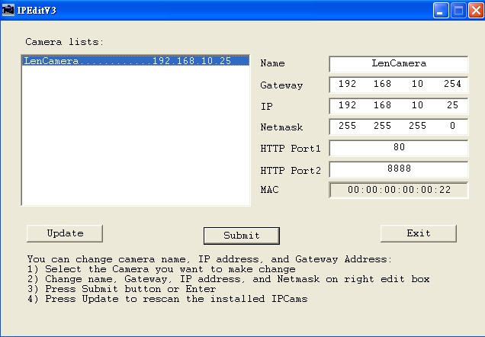
Online with DHCP Server

10.1.2 Online without DHCP Server
1. Use IPEdit.exe to find the installed Network DVR.
2. The Internet DVR without IP allocated by DHCP will have a default IP Address of 169.254.1.13.
3. Select this Internet DVR on Camera List Window.
4. The default configuration will be shown on the right window.
5. Under DOS mode enter “IPCONFIG” to access Geteway, IP, and Netmask setting values.
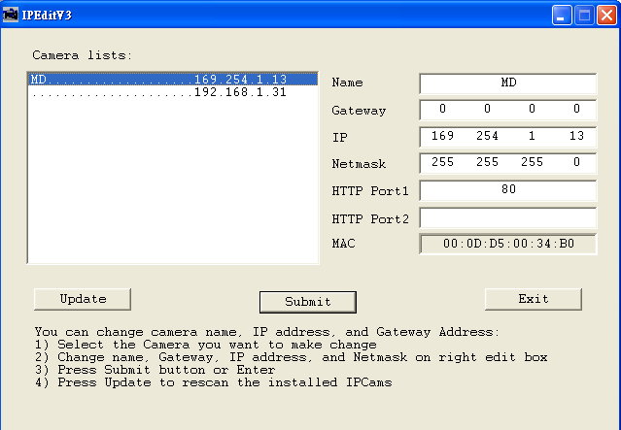
Online without DHCP Server

After the “Submit” button is clicked, the IP information of this Network DVR will be updated.

10.2 Connecting Network DVR
3 methods for connecting Network DVR:
- Online using Intranet or Fixed IP
- Online using ADSL (PPPoE) Router
- Online using DDNS Server

10.2.1 Online using Intranet or Fixed IP
Setup similar to “9.1 Network DVR Setup” .

10.2.2 Online using ADSL (PPPoE) Router
Setup similar to “9.4.3.3 Connect to ADSL by PPPoE mode”.

10.2.3 Online using DDNS Server
The DDNS service provides the dynamic IP to users to gain access to resources connected to the Internet via a cable or DSL connection. Once you’ve decided to apply this function, please register your domain name at http://www.dyndns.org (this website supports register free service). Paid DDNS service is applied to long-term users. For more information, please refer to “9.4.4 DDNS Setup”.

10.2.4 Online Connection
Start the Internet Explorer, enter the IP Address of the Network DVR into the Address field, such as 192.168.1.31 or click twice on IPEdit.
Before connection, “User name” and “Password” will be requested:
Default User Name: admin
Default Password: 1234
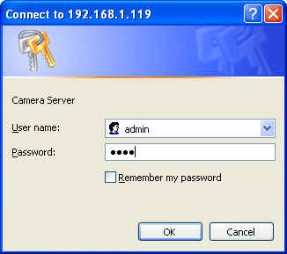

10.2.4.1 Install ActiveX
Before entering remote connection, please install ActiveX and check your browser setup by following the procedures below:
a. Open Internet Explorer under “Tools”, select “Internet Options”.

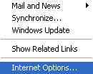
Tools → Internet Options

b. Select “Security”, and then press “Custom Level”.
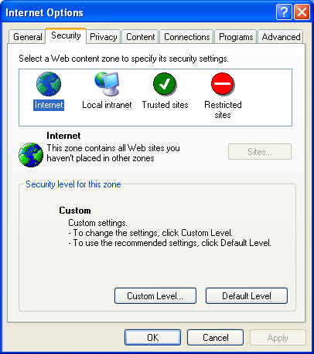
Security -> Custom Level

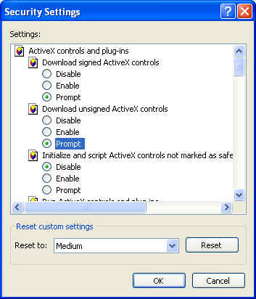
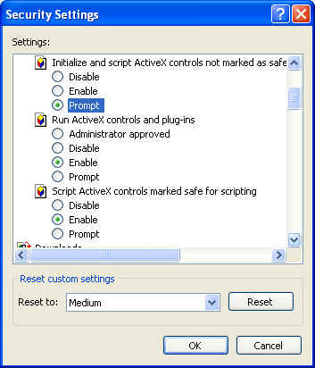
Start-up ActiveX Control

The graphic below will be shown when first time installing ActiveX Mode. Please, select “Yes” to accept installation.
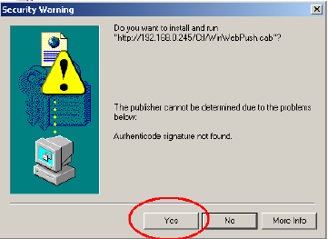
Download ActiveX Control

Live view will be displayed when installation is successful.
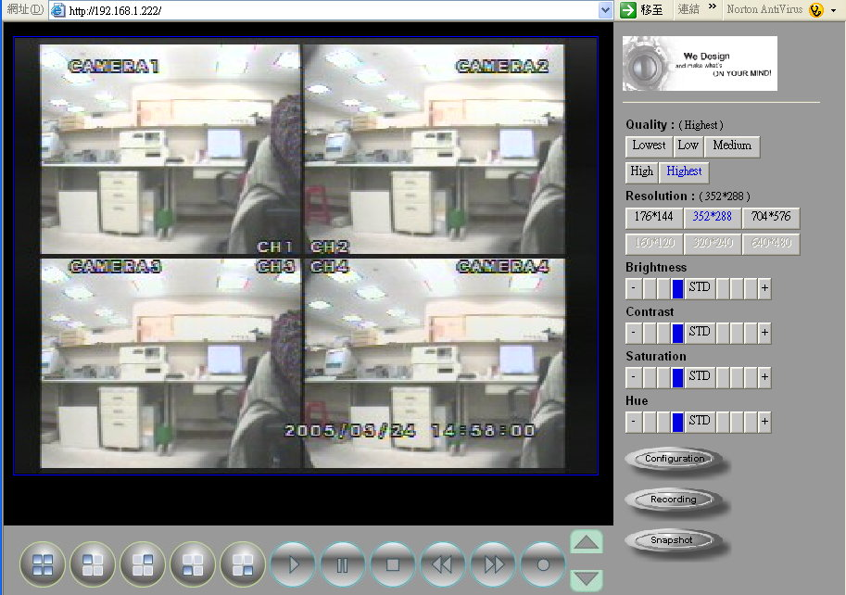
Live display under ActiveX mode

10.3 Main Display
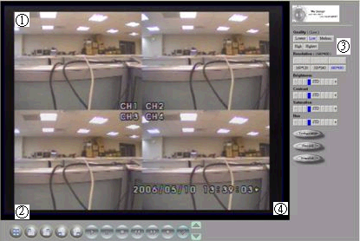
Remote control DVR - Main Menu
Live Display
DVR Control Button
Video Setup
Configuration: Enter detail setup
Recording: Displays recording setup menu (for video recording).
Snapshot: Pop-up window displays live images, right mouse click to save.
Note! To view complete interface, PC resolution must be adjusted to 1024*768.

10.3.1 Live Display
- View/ Make changes on image display
- Rotate/ Make changes on image direction
- Image Recording/ Record function setup
- Save Current Picture/ Save the current image
- Welcome! Administrator/ Display current user name
- About/ Version description
Move the cursor inside the image range, right mouse click to display 9 function selections:
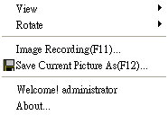

10.3.2 View
Two types of display method:
- Resizable: Adjustable image size.
- Actual size: The actual image size.

10.3.3 Rotate
Four types of rotate settings:
- Rotate 0: Default state
- Rotate 180: Rotate the image by 180 degrees.
- Flip horizontal: Image flips horizontally
- Flip vertical: Image flips vertically

10.3.4 Image Recording
Image Recording Setup Display:
Save as JPEG: Save as picture file
Save as AVI: Save as AVI animation file
Save as JPEG:
No Limit: Unrestricted image storage (continuous).
Number: Image storage according to “number”.
Save interval: Image storage according to “1/10 second” (e.g.: Enter “10”, then 1 frame is stored per second. Enter “50”, then 1 frame is stored in 5 seconds).
Size: Image storage according to “size”.
Time: Image storage according to “time”.
Save Path: Image storage according to “Save Path”.
Pre Name: Image storage according to “Prefix Name”.
Save as AVI:
No Limit: Unrestricted image storage (continuous).
Number: Image storage according to “number”.
Save interval: Image storage according to “1/10 second” (e.g.: Enter “10”, then 1 avi file is stored per second. Enter “50”, then 5 avi files are stored in 5 seconds).
Size: Image storage according to “size”.
Frame Rate: Image storage according to “frame rate”.
Time: Image storage according to “time”.
Maximum Number of Frame in Each File: Image storage according to “maximum frame”.
Save Path: Image storage according to “Save Path”.
Pre Name: Image storage according to “Prefix Name”.
Note: Only one storage format may be selected, either by JPEG or AVI.

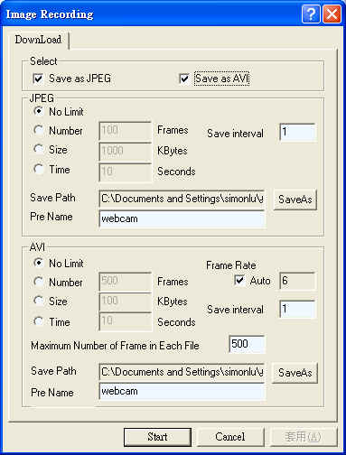

10.3.5 Save Current Picture
Select to save live images.

10.3.6 DVR Control Setup
Supports DVR remote control function (Please refer to 6-1 Front Panel Buttons and Controls, on page 8).

10.3.7 Quality Setting
Network DVR provides 5 image quality settings. The user can select the quality setting from the “Quality” list box.
- Highest
- High
- Medium
- Low
- Lowest

10.3.8 Resolution Setting
Network DVR provides six resolution settings. The user can select the quality setting from the “Resolution” list box.
- 176x144
- 160x120
- 320x240
- 352x288
- 640x480
- 704x576
Note! The device supports auto video system detection (NTSC/ PAL).

10.3.9 Advance Settings
Network DVR provides the advanced settings for the following:
- Brightness
- Contrast
- Saturation
- Hue

10.4. Configuration
Only the administrator can select the “Configuration”; the ordinary user account does not have this privilege to access this function.

10.4.1 System Setting
The number on Port 1 and Port 2 may be changed, press “OK” button to save the setting.
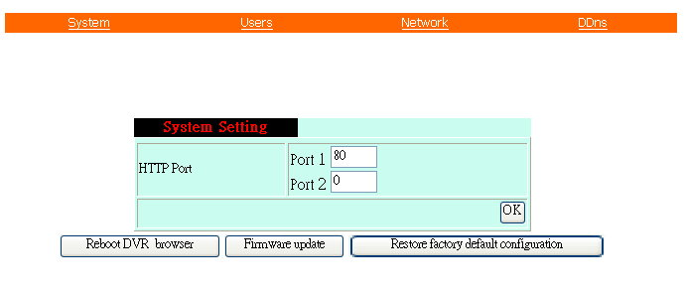
System Setting Display

- Reboot DVR: The system need 20 seconds to reboot the DVR (Rebooting does not effect the recording function).
- FirmWare update (Please refer to 6.7).
- ReStore Factory Default

10.4.2 User Setting
- User Authorization Setting
- Add User or Change Password
- Delete User Account
- Current Users
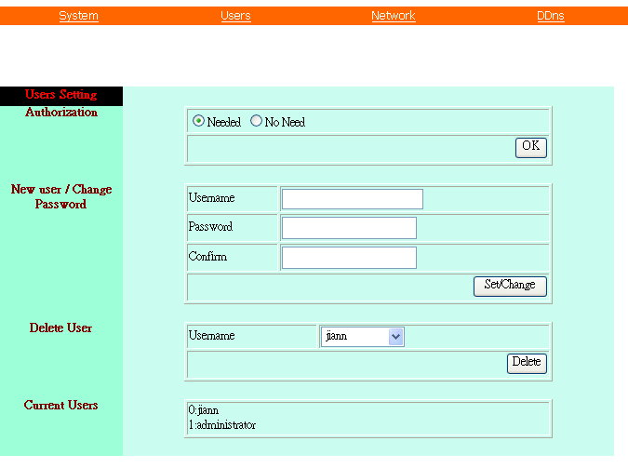
User Setting Display

10.4.2.1 User Authorization Setting
Select item “Needed” to enable user authorization function, then each time before login to Network DVR the Login window will request for “Username” and “Password”. To disable user authorization function, select item “No Need”.

10.4.2.2 New user/ Change Password
Enter a new user name and password information to create a new user account, or enter an existing user account, then set a new password to replace the old password, and select “OK” to create the account or change password. After selecting “OK” button, the “Current User List” would display the newly created user account (Maximum 20 users, user name and password setup are limited to 10 characters).

10.4.2.3 Delete User
Enter the user account that you wish to delete, click “OK” to delete the account. After selecting “OK” button, the selected user account will be deleted from the “Current User List”.

10.4.3 Network Setting

10.4.3.1 Fixed IP
To setup follow the steps below:
1. Select item “Manually”.
2. Enter “IP Address”, “Subnet mask”, and ”DNS”.
3. Click “OK” button to save the setting.

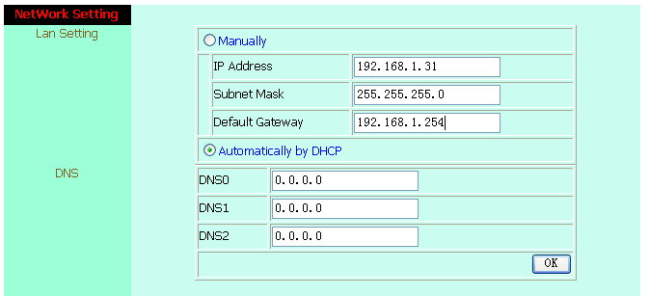
Network Setting Display

10.4.3.2 DHCP
The “DHCP” is automatically set as the default network setting of the Network DVR. When a Network DVR is connected into the LAN, it will issue DHCP packets to request an IP address that is dynamically assigned by the DHCP server. If it is unable to get a DHCP address on a limited tries, the Network DVR will assign a default IP address such as “169.254.1.13”.

10.4.3.3 Connect to ADSL by PPPoE mode
To setup follow the steps below:
1. After setup, rebooting enables automatic connection to ADSL.
2. Enter the “Username” and “Password” fields with the account and password provided by the ISP.
3. If item “Send mail after connected” is selected, the mail will be automatically sent when connected to the ISP.
4. Click “OK” button to save the settings.
Note: In order to activate the function, it is necessary to reboot the device after the setup.

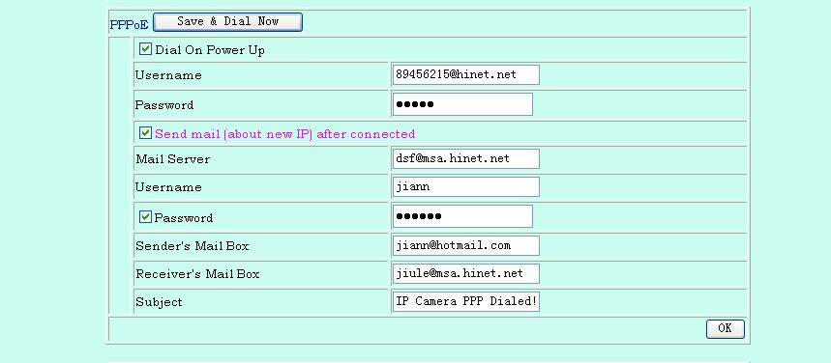
1
2
ADSL Setting Display

If the Network DVR and ADSL modem are connected by a hub, the user can select item “Dial On Power Up” to perform the connect operation. On contrary, if the Network DVR and ADSL modem are connected directly, then please note the following steps below:

1. Power off Network DVR.
2. Connect Network DVR directly to the ADSL modem (using RJ-45 Ethernet port).
3. Power-up Network DVR.
4. Network DVR start dialing.
5. Once connected, mail the IP address information to the preset e-mail address.
6. After 10 times of connection failure, it aborts the operation and the user can reconnect it by LAN to find the cause.
Note: If item “Send mail after connected” is selected, then the Network DVR will send a mail that contains the message “Dial Up IP Address/ Netmask/ Gateway/ DNS Server” will be mailed to the preset e-mail address.
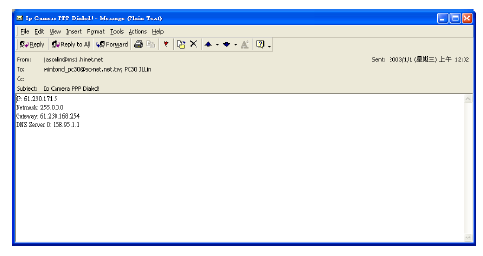
Connection Message Send to User

10.4.4 DDNS Setting
Press “DDNS” server connection to start-up the function. It can autonomously and automatically contact DDNS provider service whenever the router detects that its public IP address has changed. The router logs on to an account you setup and maintain, and updates the account with its latest public IP address. You may register at DDNS Server: http://www.dyndns.org.
To setup follow the steps below:
- Register at DDNS Server: http://www.dyndns.org.
- Apply domain name.
- Click the “Enable” button. Enter “UserName” and “Password” with “DomainName”.
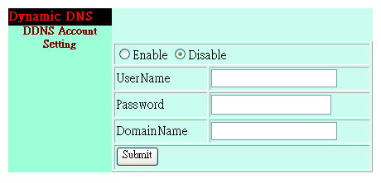
DDNS Setting

After registering the domain name, please enter the information supplied by the administrator to the Network DVR DDNS Account Setting. Select “Enable” button to start-up DDNS server, and press “Submit” button to save the setting.

Note: To enable “Disable” function, please reboot the device after disable function has been setup.

10.4.5 Firmware Update
When new firmware (bin file) is supplied, you may update the new version firmware (bin file) to your PC by following the procedures below:

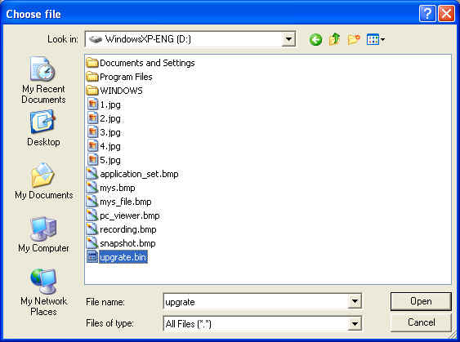

Select the Firmware to be Updated

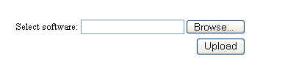
Uploading the Selected Firmware

Press “Upload” button to display the message below, and follow the instruction to make the necessary setup.

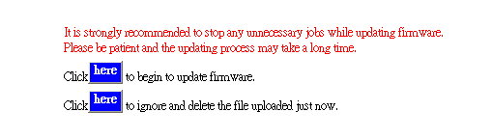
(1)
(2)
Firmware Update

Press “here” button (1) to update Firmware. Press “here” button (2) to delete the file. The message below displays the writing progress of the firmware update. When Firmware update is completed, it will show 100%, and a message “Click here to reboot DVR browser” will be displayed, requesting to restart the Network DVR.
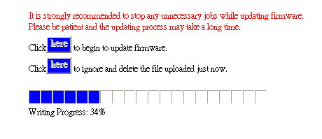
Firmware Update Display

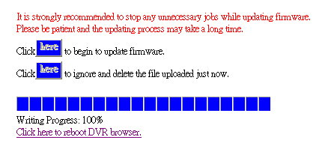
Firmware Update Completed, prompt to restart the device.

11. HDD Player Software Description
PC Player Software
System Requirement
※ OS (Operating System) Windows XP or later.
- Use your PC to install DirectX (version DirectX 7.0 or above).
- Using remote control software, please setup the resolution to 1024x768 or above.

Hardware Requirement
※CPU 1.0 GHz or higher.
※RAM 512 Mbyte or higher.

1. Installation
A. Hardware Installation
Make sure that HDD is connected through IDE or USB interface to the PC.

B. Software Installation
- During installation, you will need a desktop or laptop computer that meets these minimum requirements: Windows XP.
2. Copy the PC Player Software to your PC (under any directory, e.g.: C:\ ). When user start-up PC Player Software, it will auto create a directory “_config”, the purpose is to store all parameter setup supplied by the PC Player Software.

2. Operation
Move the cursor to PC Player Software and double left mouse click to proceed. When proceeding PC Player Software, it auto-detects the HDD (about 1 min. to auto detect, and may differ depending on file size).
※ | Network DVR does not support player software other then PC Player software.

3. Software Playback Interface Description
A. User Interface
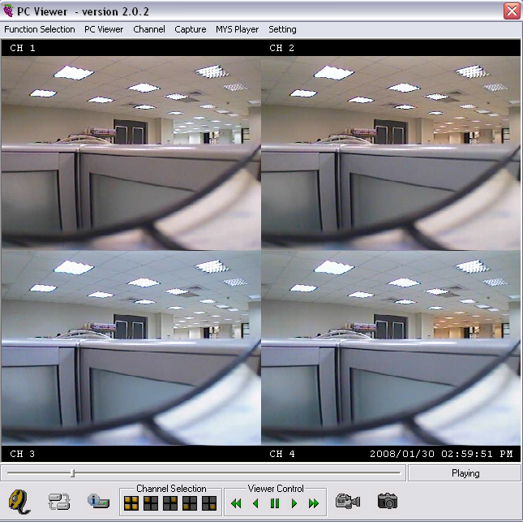

System Status

Figure 1

When the system detects stored materials (HDD), the above graphic (Figure 1) will be shown. User may operate the function buttons to make necessary playback adjustment or store recordings onto the PC.

 | ： | Fast Rewind |  | ： | Rewind
 | ： | Pause Playback |  | ： | Forward
 | ： | Fast Forward |  | ： | Quad split screen display
 | ： | CH1 Full Screen Display |  | ： | CH2 Full Screen Display
 | ： | CH3 Full Screen Display |  | ： | CH4 Full Screen Display
 | ： | Click this button to capture images as BMP file, graphic shown by “Figure 2” will be shown and PC Player Software auto creates storage content “9821”.
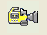 | ： | When recording videos onto the PC, first click the “Pause” button, then “Now Recording” button on the graphic shown by “Figure 3”. Click again to stop recording (shown on the graphic by “Figure 4”) and the PC Player Software auto creates storage content “Capture MYS”.
 | ： | Click this button to playback recorded materials (stored on PC); graphic show by “Figure 5” will be displayed. Please select the file to playback, press “open” to playback. This button function is similar to “File Player” function.
 | ： | Click this button to shut the system.

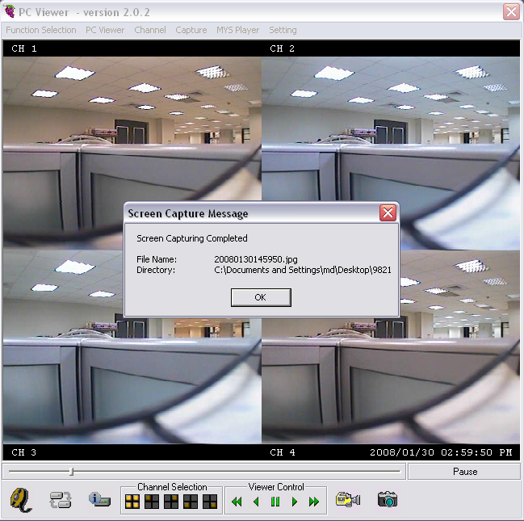

Figure 2

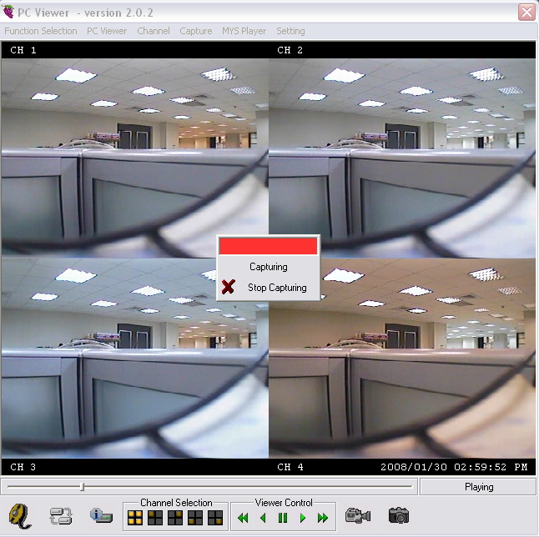

Figure 3

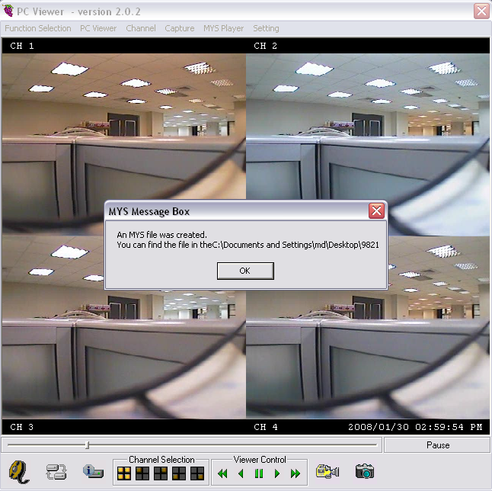

Figure 4

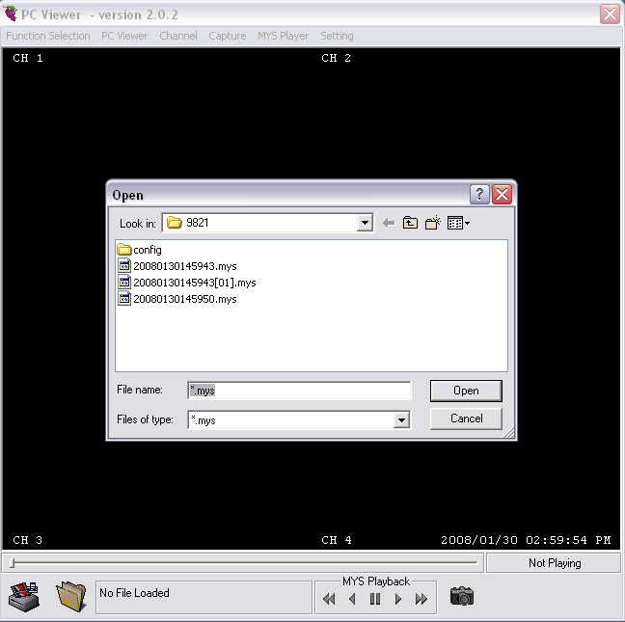

Figure 5
B. Parameter Setup
Click “Standard Setup” button to show the graphic display below (Figure 6). User may use “Change” button to setup MYS and JPEG file storage directory:
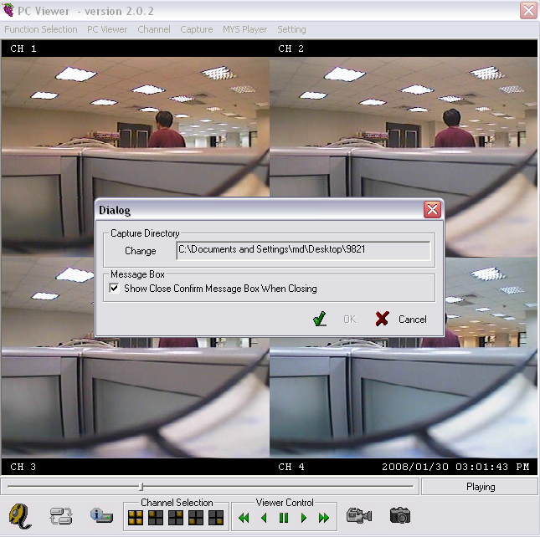

Figure 6

12. TROUBLESHOOTING

Question | Answer
Suggested HDD Brand | Maxtor, Seagate, and Hitachi.

13. SPECIFICATIONS

Video | Format | NTSC/EIA or PAL/CCIR
Video | Compression | M-JPEG
Video | Input | 4CH, BNC
Video | Output | 1 x BNC
Display | Resolution | 720 x 480 (NTSC)， 720 x 576 (PAL)
Display | Frame Rate | Max. 120/100 fps (NTSC/PAL)
Display | Division | Single, Quad
Recording | Resolution | Max. 640 x 224 (NTSC)， 640 x 272 (PAL)
Recording | Frame Rate | Max. 120/100 fps (NTSC/ PAL)
Recording | Quality | High / Normal / Low
Recording | Mode | Manual / Schedule / Motion Detection
Alarm | Trigger Mode | Motion Detection
Alarm | Function | Recording, Sound Alert
HDD |  | 1 x 3.5” IDE HDD (Max. 500GB)
Post Alarm |  | 1~60sec
Search Method |  | By Date, Time, Event
Network (optional) |  | 10/100BaseT Ethernet(RJ45)
Backup Device |  | HDD, USB
Power Supply |  | DC 12V 2A or above
Weight |  | 2.5kg (without HDD)
Dimension (W*H*D) |  | 195mm x 45mm x 226mm
Operating Environment |  | 30 ~ 80% RH, 5ﾟC ~ 40ﾟC (40ﾟF ~ 104ﾟF)
Remote Control |  | IR Transmission

